

|  |  |  |  |  |  |  |  |  |
| --- | --- | --- | --- | --- | --- | --- | --- | --- |
|  | | | | | | | | |
|  | | Ticket Prediction ML Model | | | | |  | |
|  |  | | | | | | |  |
|  | | | |  |  | | | |
|  | | | | Internship Project Report bySS Madhuvani Petla |  | | | |
|  | | | | 24-Jul-22—Mentor: Swati Banka—NTT DATA |  | | | |
|  | | |  | | |  | | |



|  |  |  |  |  |  |  |  |  |  |
| --- | --- | --- | --- | --- | --- | --- | --- | --- | --- |
|  |  | | |  |  | | | |  |
|  | Content | | | | | | | |  |
|  |  | | |  |  | | | |  |
|  |  | |  | | |  | | |  |
|  |  |  | 1. Introduction 2. Abstract 3. Problem Definition and Algorithm    1. Task Definition    2. Algorithm Definition 4. Statistical Analysis 5. Machine Learning Models Used    1. ARIMA    2. LINEAR REGRESSION    3. XG BOOST    4. 6 months tickets (XGBOOST) 6. Related Work 7. Worklog 8. Future Work 9. References 10. Conclusions | | | |  | 3  4  5-7  5  6-7  8-15  16-43  17-20  21-29  30-39  40-43  44  45  45  46-47  48 |  |
|  | | | | |  | |

|  |  |  |  |  |  |  |  |  |
| --- | --- | --- | --- | --- | --- | --- | --- | --- |
|  | | 1.Introduction | | | | |  | |
|  | |  |  | | |  |  | |
|  | Use of Machine Learning for the Project?**1. You’ll gain valuable insight for future Ticket Predictions** Forecasting gets you into the habit of looking at past and real-time data to predict future demand. And in doing so, you’ll be able to anticipate demand fluctuations more effectively. But more than that, it’ll give your insight into the company’s health and provide you with an opportunity to course-correct or make adjustments. **2. You’ll learn from past data** You don’t start from scratch after each forecast. Even if your prediction was nowhere close to what ended up coming to pass, it gives you a starting point. It’s common to review where and why things didn’t happen the way you predicted. Your forecasts should eventually improve. But more than that, you’ll get into the habit of reflecting upon past performance as a whole. And self-reflection can be a powerful driver of company growth. **3. It can decrease costs of labor** When done right, anticipating demand will help you tweak your processes to increase efficiency all along the supply chain. Because you’re better able to predict what customers will want and when they’ll want it, you may also be able to decrease excess inventory levels, thus increasing overall profitability. | | | | | | |  |
|  | Benefits for the current Problem statement or Use case Since Ticket Prediction is a task that can consume an ample amount of the cost of labor this prediction Model can help perform contingency planning during the challenging financial times. | | |  | This makes a better future prediction of the work planning and the cost of time and cost of labor. By categorizing the predicted tickets, we can achieve the requirements. | | |  |

|  |  |  |  |  |
| --- | --- | --- | --- | --- |
|  | 2.Abstract | | |  |
|  |  |  |  |  |

**This abstract describes about the use case that we’ve worked on. In the given problem statement the task was to predict the total number of tickets that can be recorded in a particular day of the year or on a particular date. This can be achieved by applying a time series machine learning model on the past data. The time series model mainly takes an overall analysis of the seasonality, trend, irregularity and cyclic nature of the data. There are many time series models that can work on the past data to give future predictions. This report discusses of the different types of models that were used in the analysis and prediction of the number of tickets. The predicted data is then tested with the actual data and the accuracy is then calculated. Out of all the time series models, XGBoost has given the best accuracy which we will be discussing in the report. The given data has been a univariate data with almost no seasonality, trend, irregularity or cyclic nature which made the task tough. The data was first analyzed and the required operations on the data are performed to achieve the best results. After the prediction of data, the predicted value can be further divided or segregated to different categories to give complete analysis for the company about the requirements of the ticket resolution. References are attached in the end of the of the report with provided GitHub link.**

|  |  |  |
| --- | --- | --- |
|  | 3.Problem Definition and Algorithms |  |

##### 3.1. Task Definition

The use case given for the project is to predict the total number of tickets on a given date and further categorize the tickets according to the priority.

##### Ticketing System

Ticketing tool in SAP are **generally used to handle production support environment**. However, they are some third-party tools that we use to track the issues coming from the end users. Depending on the company and client the tools can vary. SAP Event Ticketing offers us a scalable and innovative platform to provide our customers with the best service possible.

These tickets are then resolved by the technical experts.

The ticketing process normally in SAP is 3 levels.

* High Priority
* Medium Priority
* Low priority

If it is High Priority, you should solve the issues within **2 hrs. or 3 hrs**. If it is Medium Priority, you should solve the issues within **4 to 6 hrs. or 8 hrs**. If it is Low Priority, you can solve the issues within **8 hrs**. or **next day** itself. The time dependencies may depend upon the client to client.

We should now build a machine learning model that predicts the total no of tickets and categorize according to the priority. The past data is used to train the model we are now provided with data that contains 97125 records of data that describes the details of every ticket that has been recorded for the past 2 years roughly from **27-02-2020** t0 **06-05-2022.**

##### 3.2. Algorithm Definition

##### Time-series Analysis Machine Learning model

Time series analysis is a specific way of analyzing a sequence of data points collected over an interval of time. In time series analysis, analysts record data points at consistent intervals over a set period of time rather than just recording the data points intermittently or randomly.

Time series analysis typically requires a large number of data points to ensure consistency and reliability. An extensive data set ensures you have a representative sample size and that analysis can cut through noisy data. It also ensures that any trends or patterns discovered are not outliers and can account for seasonal variance. Additionally, time series data can be used for forecasting—predicting future data based on historical data.

##### Why should we use time-series analysis for this use-case?

 Time series forecasting is part of Predictive analysis. It can show likely changes in the data, like seasonality or cyclic behavior, which provides a better understanding of data variables and helps forecast better.

In time series data, variations can occur sporadically throughout the data:

* **Functional analysis**can pick out the patterns and relationships within the data to identify notable events.
* **Trend analysis** means determining consistent movement in a certain direction. There are two types of trends: deterministic, where we can find the underlying cause, and stochastic, which is random and unexplainable.
* **Seasonal variation**describes events that occur at specific and regular intervals during the course of a year. Serial dependence occurs when data points close together in time tend to be related.

Time series analysis is used for non-stationary data—things that are constantly fluctuating over time or are affected by time. Industries like finance, retail, and economics frequently use time series analysis because currency and sales are always changing. Stock market analysis is an excellent example of time series analysis in action, especially with automated trading algorithms.

Time series analysis and forecasting models must define the types of data relevant to answering the business question. Once analysts have chosen the relevant data they want to analyze, they choose what types of analysis and techniques are the best fit.

**Models of time series analysis include:**

**Classification**: Identifies and assigns categories to the data.

**Curve fitting:** Plots the data along a curve to study the relationships of variables within the data.

**Descriptive analysis:** Identifies patterns in time series data, like trends, cycles, or seasonal variation.

**Explanative analysis:** Attempts to understand the data and the relationships within it, as well as cause and effect.

**Exploratory analysis:** Highlights the main characteristics of the time series data, usually in a visual format.

**Forecasting:** Predicts future data. This type is based on historical trends. It uses the historical data as a model for future data, predicting scenarios that could happen along future plot points.

**Intervention analysis:** Studies how an event can change the data.

**Segmentation:** Splits the data into segments to show the underlying properties of the source information.

This current use case uses **Forecasting.**

|  |  |  |
| --- | --- | --- |
|  | 4.Statistical Analysis |  |

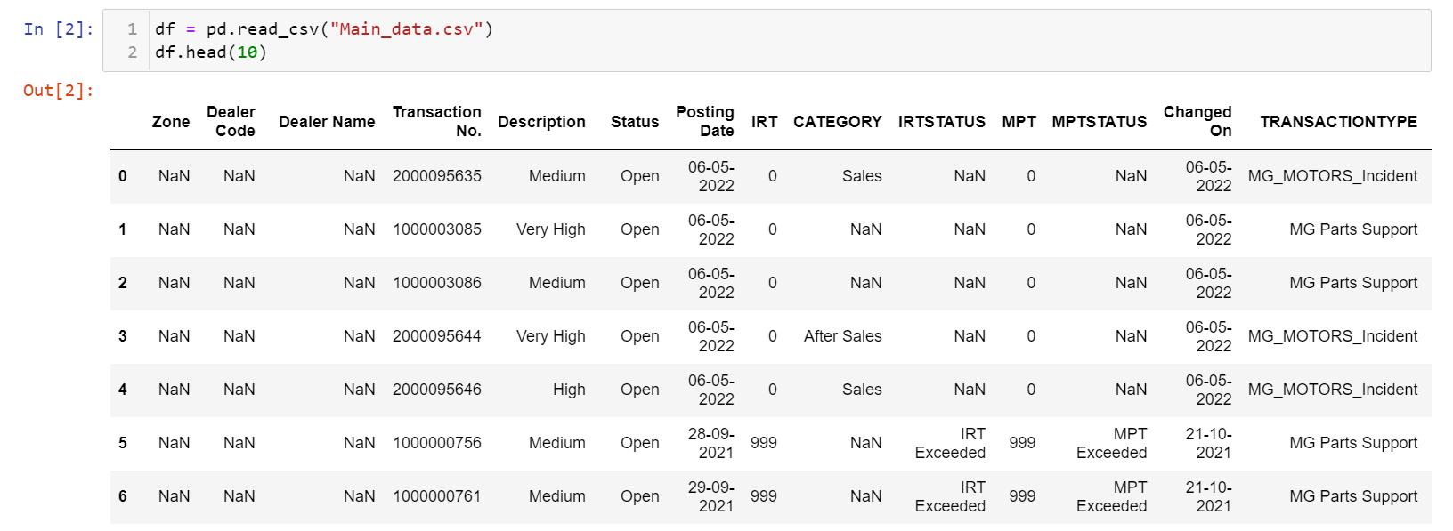This is the given data to work on.

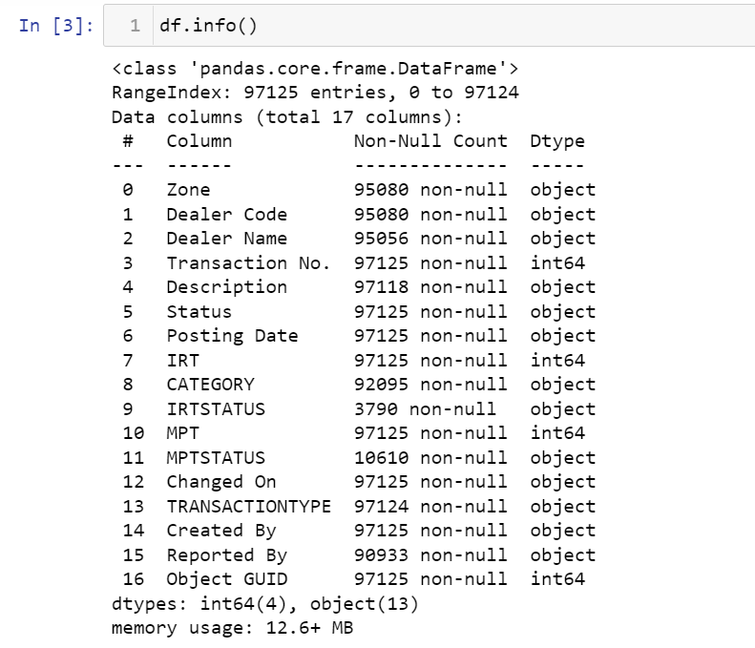

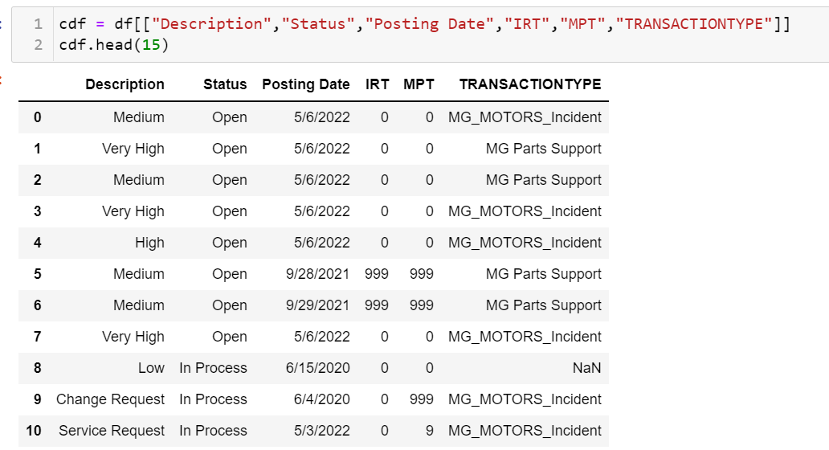

These are the Features that can be used for the classification of the tickets 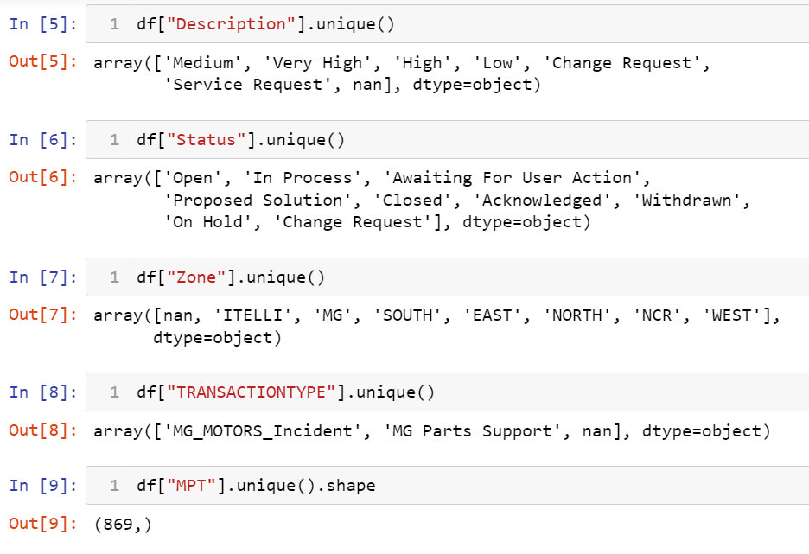

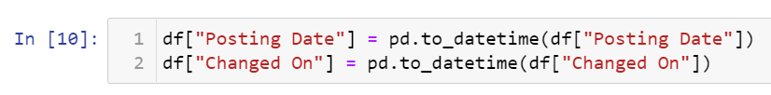Changing the string formatted dates into actual date-time format using the function t0_datetime in pandas’ library

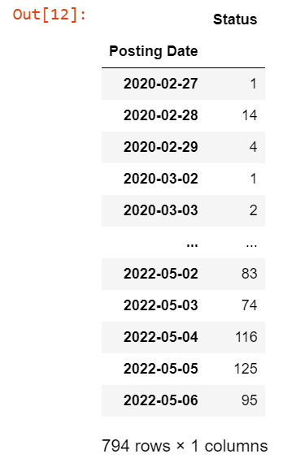Grouping the whole data into another data-frame consisting of “Posting Date” as the index for that data-frame

Resulting to the Above data

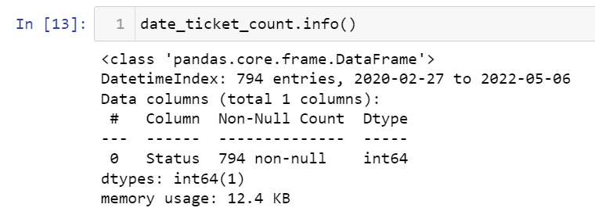

Info of the group by data

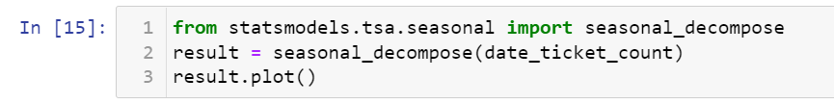

To find the Seasonality, trend, cyclic nature we import a library called statsmodels

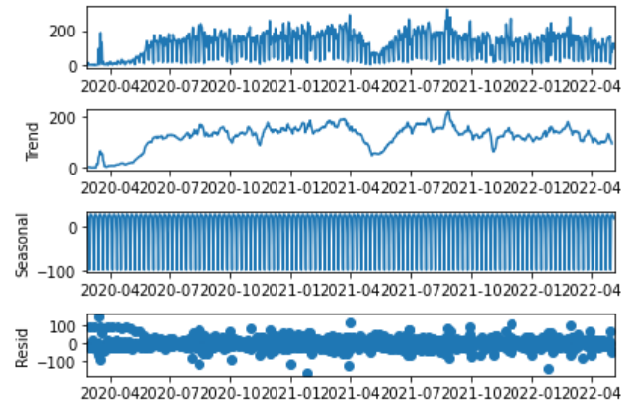There is a function **seasonal_decompose** from the class of **statsmodels.tsa.seasonal** that is used to plot the visualization of the mentioned components.

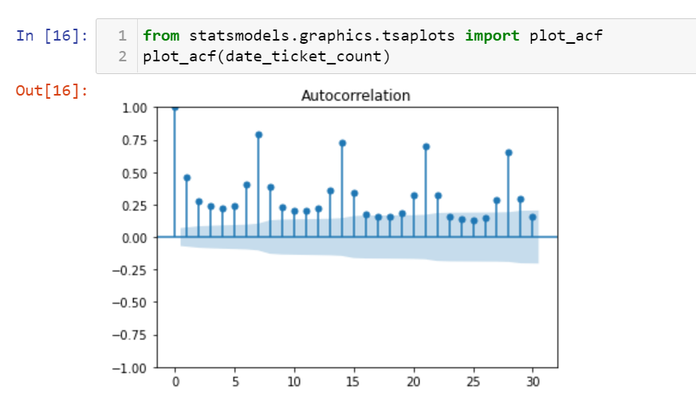Auto correlation of the data is plotted as below



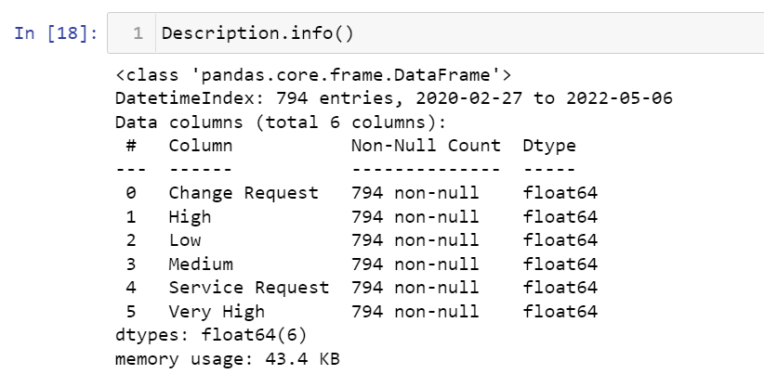

Finding the count of every individual and unique values of the “Description”, “Zone”, “Status”, “Transaction Type” in the data

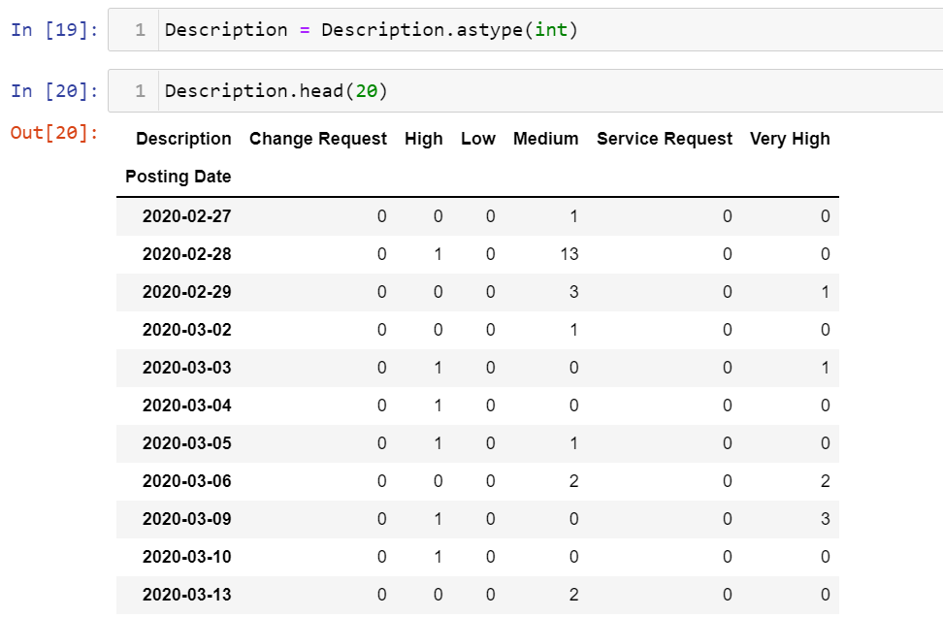

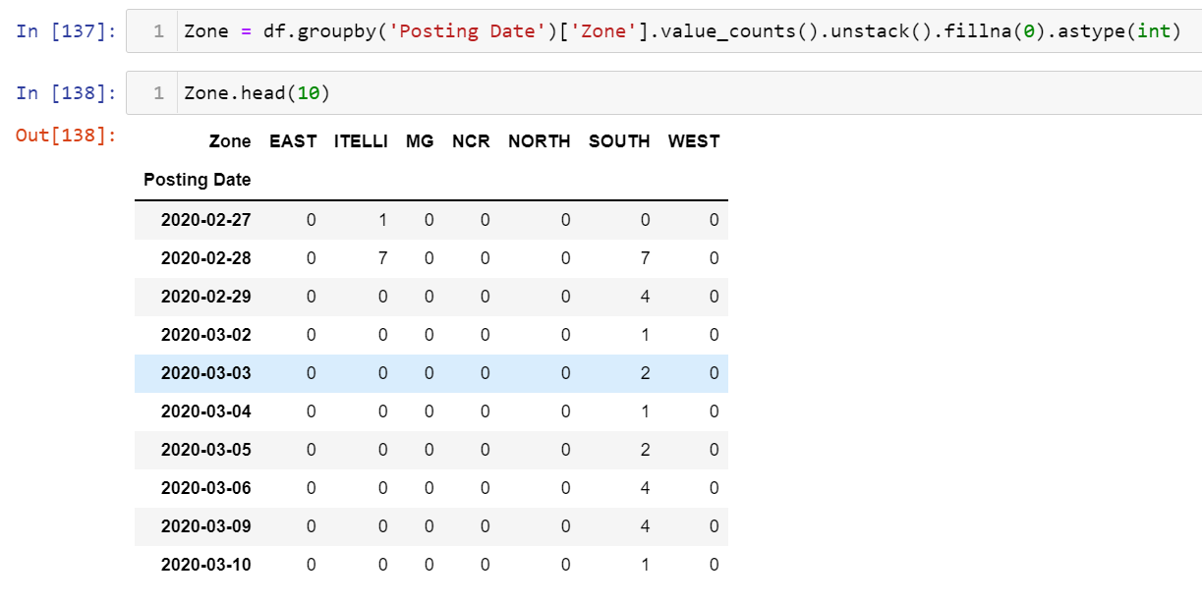

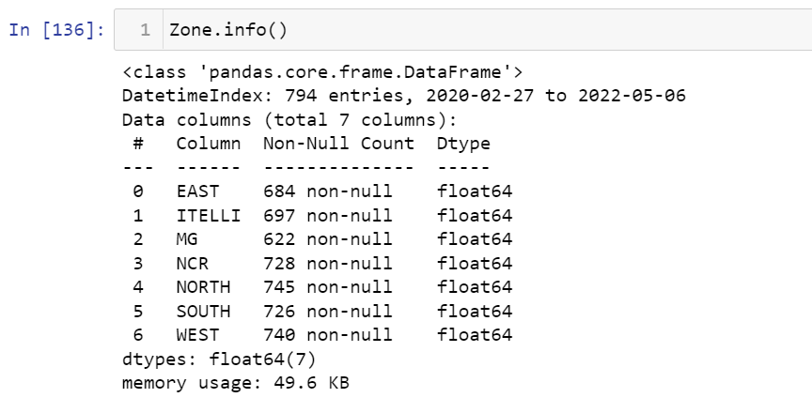

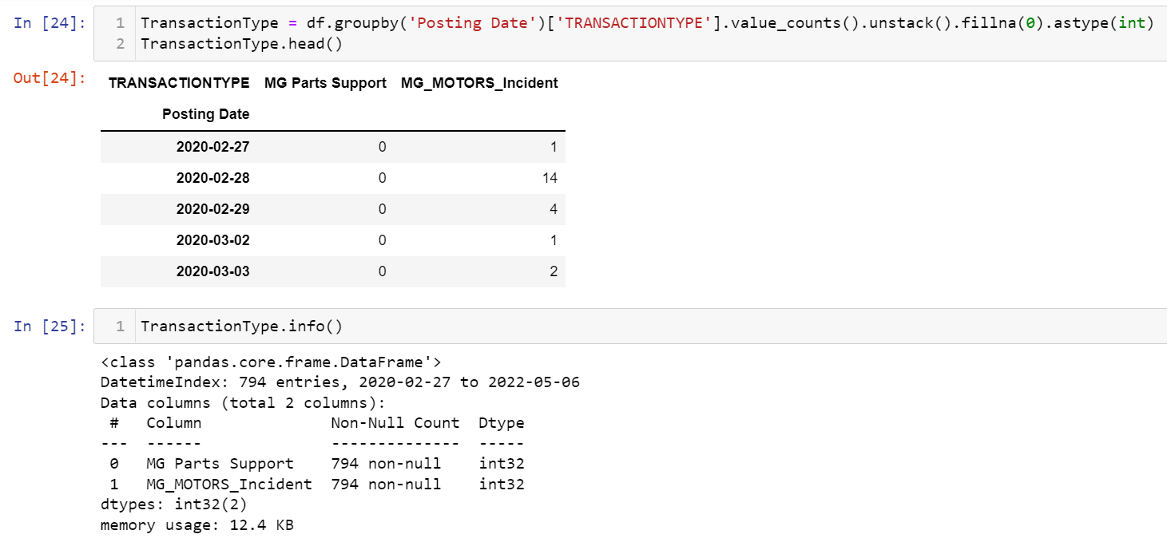

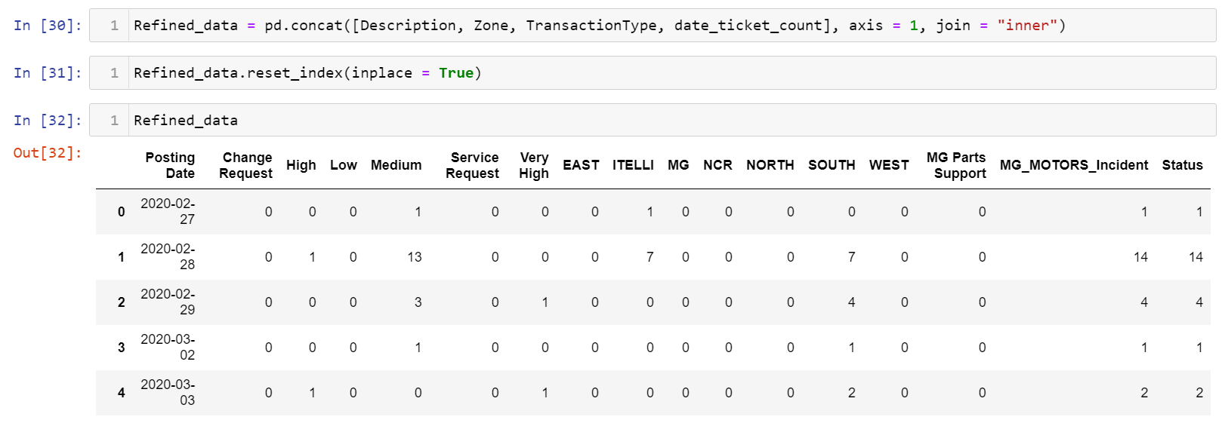

Made a data with division of data according to the categories summing up to the total tickets.

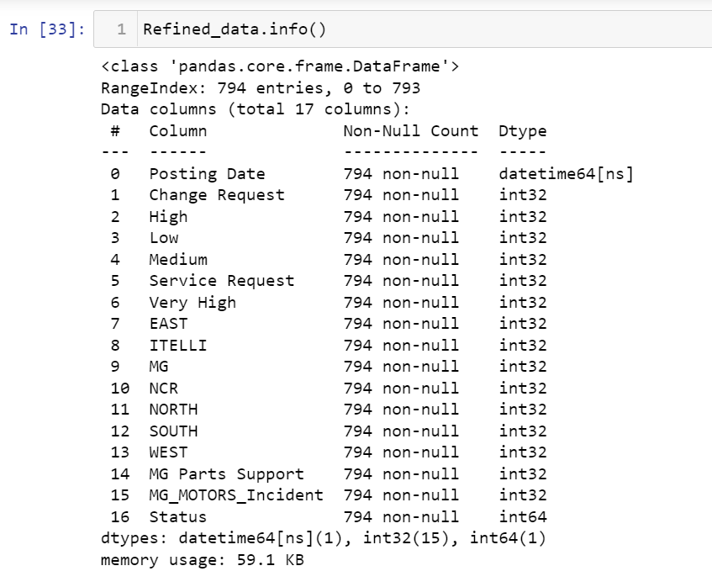

|  |  |  |
| --- | --- | --- |
|  | 5.Machine Learning Models Used |  |

##### TIME SERIES MODELS

11 different classical time series forecasting methods are:

1. Autoregression (AR)
2. Moving Average (MA)
3. Autoregressive Moving Average (ARMA)
4. Autoregressive Integrated Moving Average (ARIMA)
5. Seasonal Autoregressive Integrated Moving-Average (SARIMA)
6. Seasonal Autoregressive Integrated Moving-Average with Exogenous Regressors (SARIMAX)
7. Vector Autoregression (VAR)
8. Vector Autoregression Moving-Average (VARMA)
9. Vector Autoregression Moving-Average with Exogenous Regressors (VARMAX)
10. Simple Exponential Smoothing (SES)
11. Holt Winter’s Exponential Smoothing (HWES)

These come under the classic Time series model apart from this we have few other prediction models like:

* Prophet
* XGBoost
* LSTM
* TBATS
* Classic Linear Regression

In the current Project we will be working on 3 different models

1. ARIMA
2. Linear Regression
3. XGBOOST

In the further analysis we will find out the accuracy, errors like Root mean squared error, mean absolute error, R2 score that help in the working and performance of the model.

##### 5.1. ARIMA MODEL

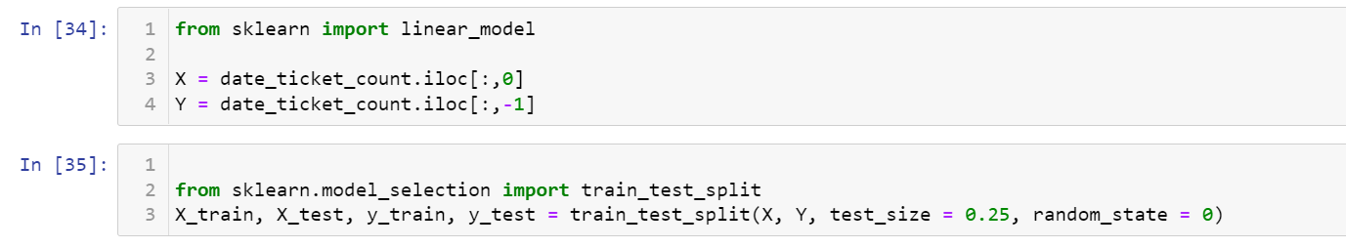

Let us first split the data that grouped using the “Posting Date”. This splitting of data can be done by the function “train_test_split” from the library sklearn.model_selection

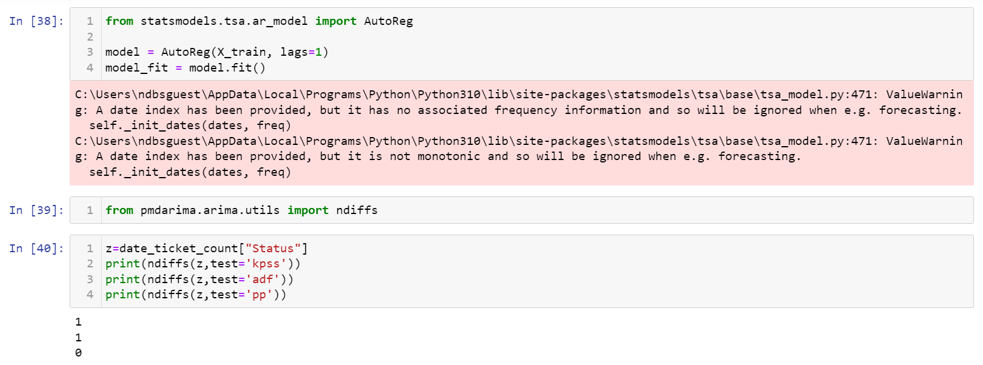

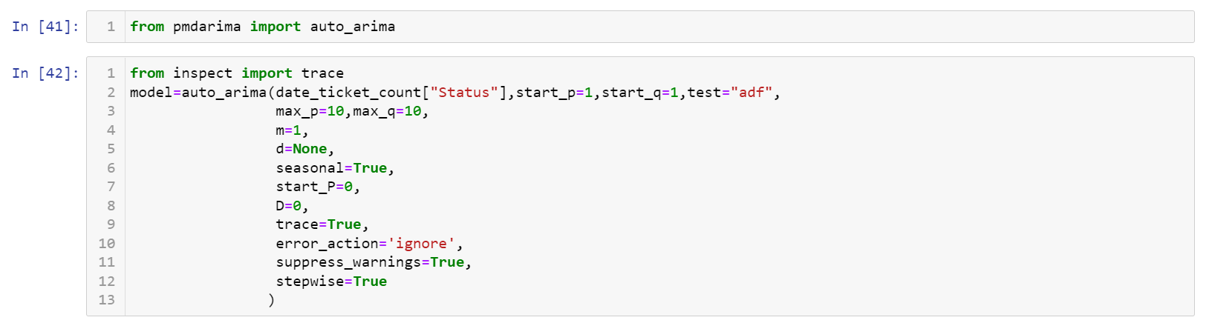

By installing the pmdarima using the command “pip install pmdarima” we can use the model.

Automatically discover the optimal order for an ARIMA model. The auto-ARIMA process seeks to identify the most optimal parameters for an ARIMA model, settling on a single fitted ARIMA model. This process is based on the commonly-used R function, forecast: auto_arima

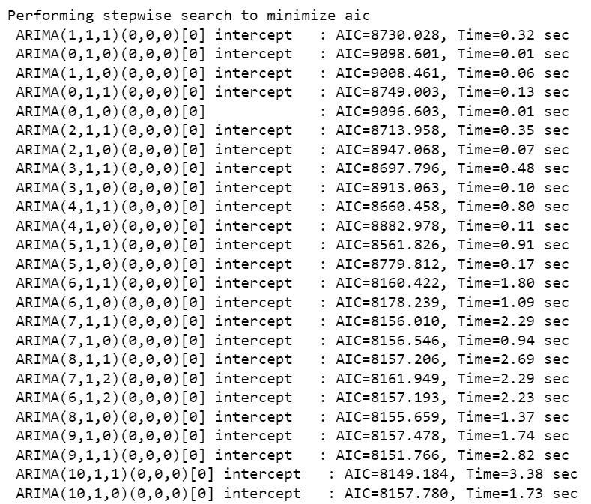

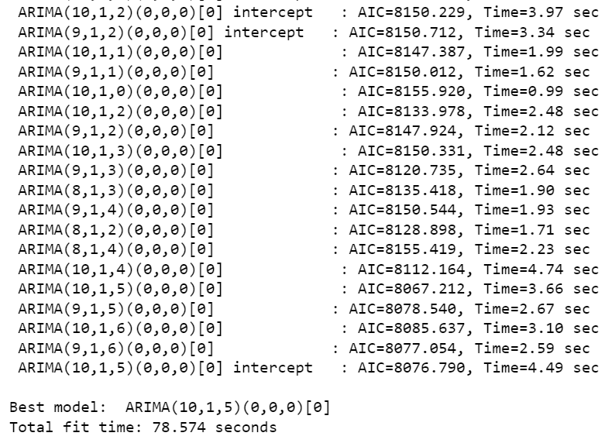

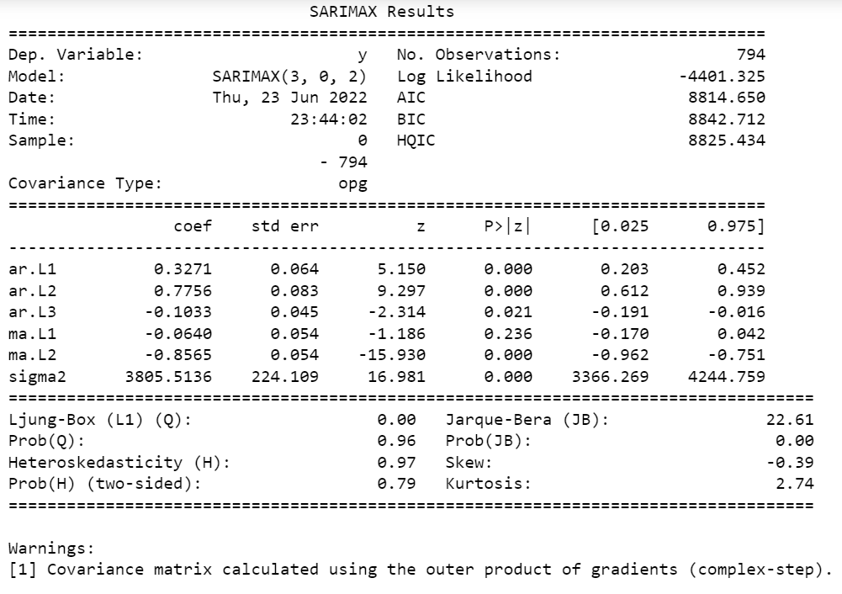

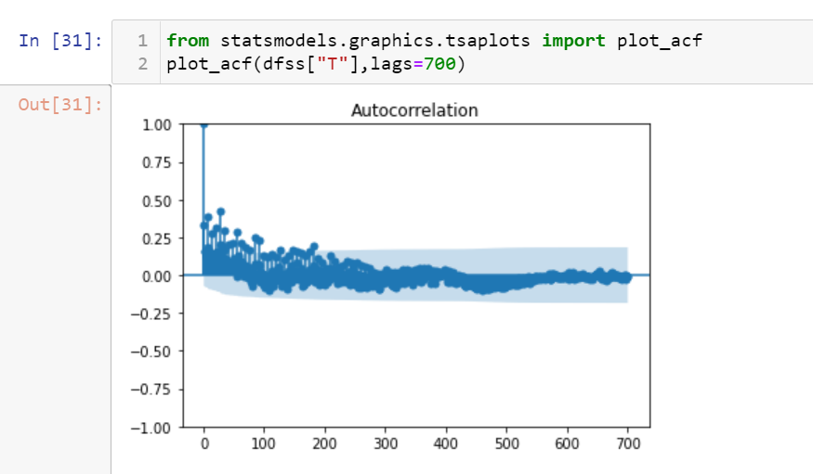

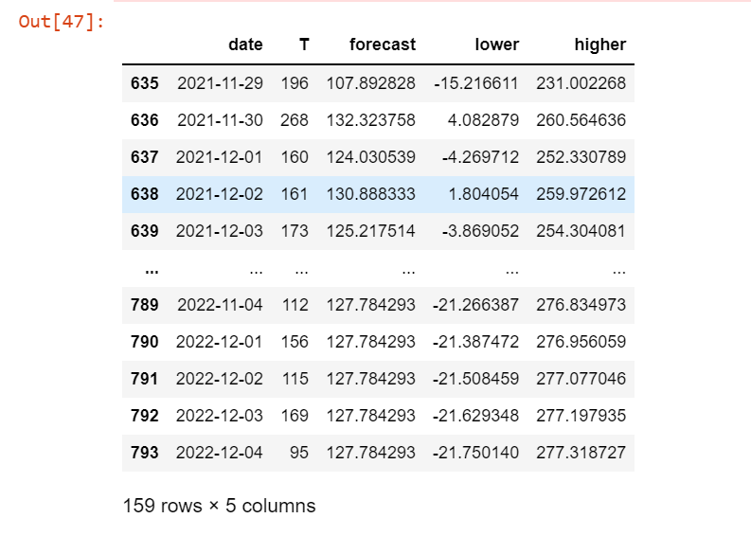

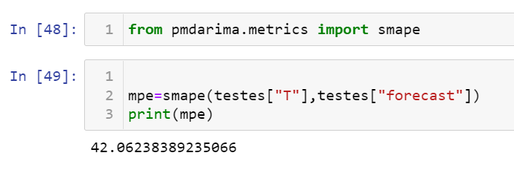

##### 5.2. Linear Regression

**Linear Regression** is a machine learning algorithm based on **supervised learning**. It performs a **regression task**. Regression models a target prediction value based on independent variables. It is mostly used for finding out the relationship between variables and forecasting. Different regression models differ based on – the kind of relationship between dependent and independent variables they are considering, and the number of independent variables getting used.

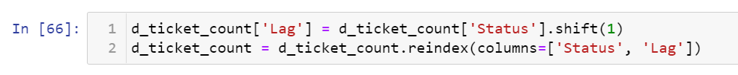

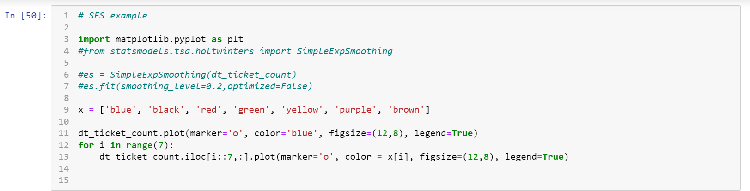

The below visualization is the entire visualization of total number of tickets

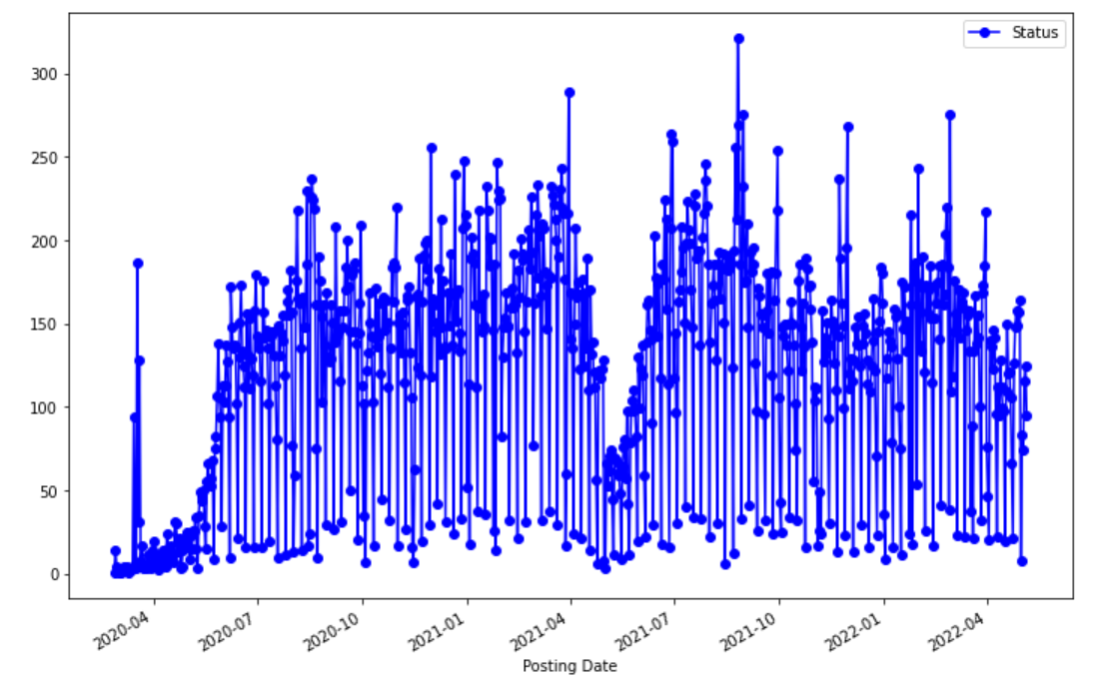

Wednesday analysis

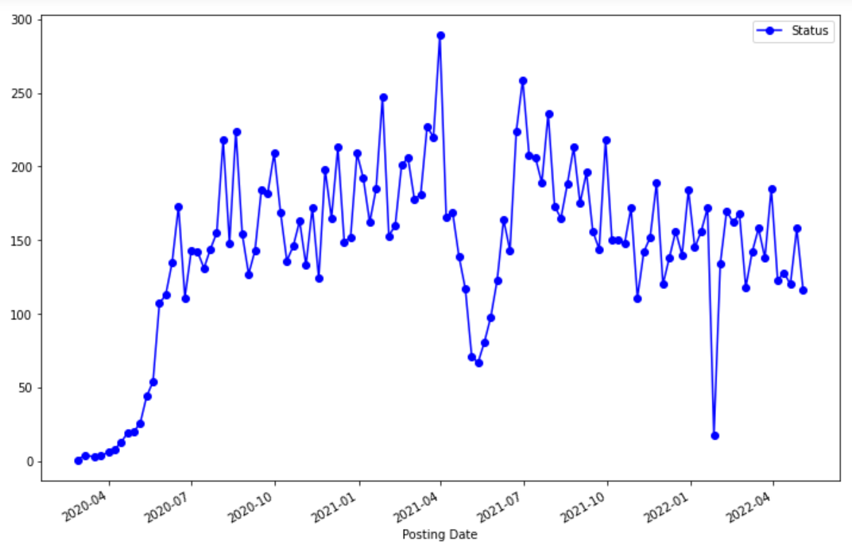

Thursday analysis

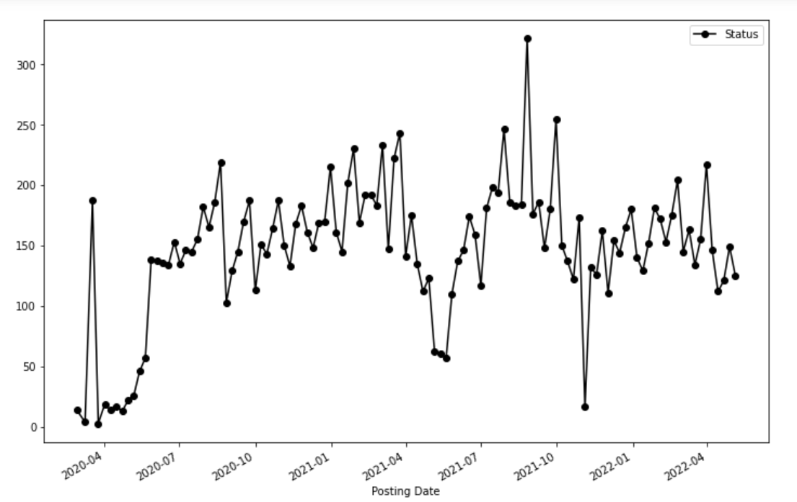

Friday analysis

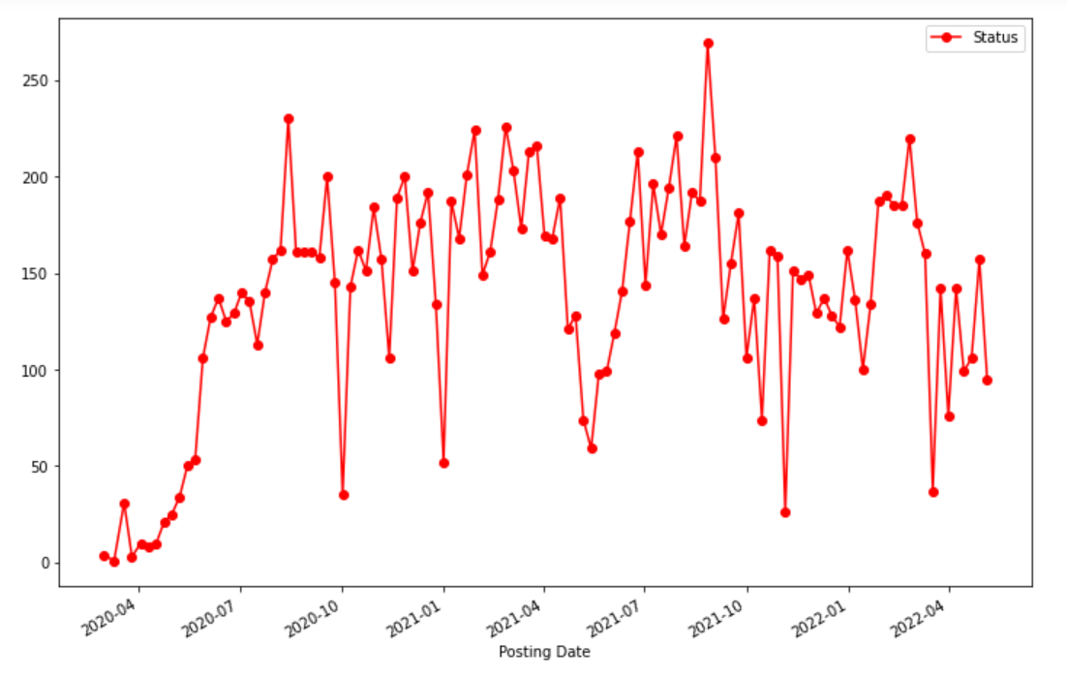

Saturday analysis

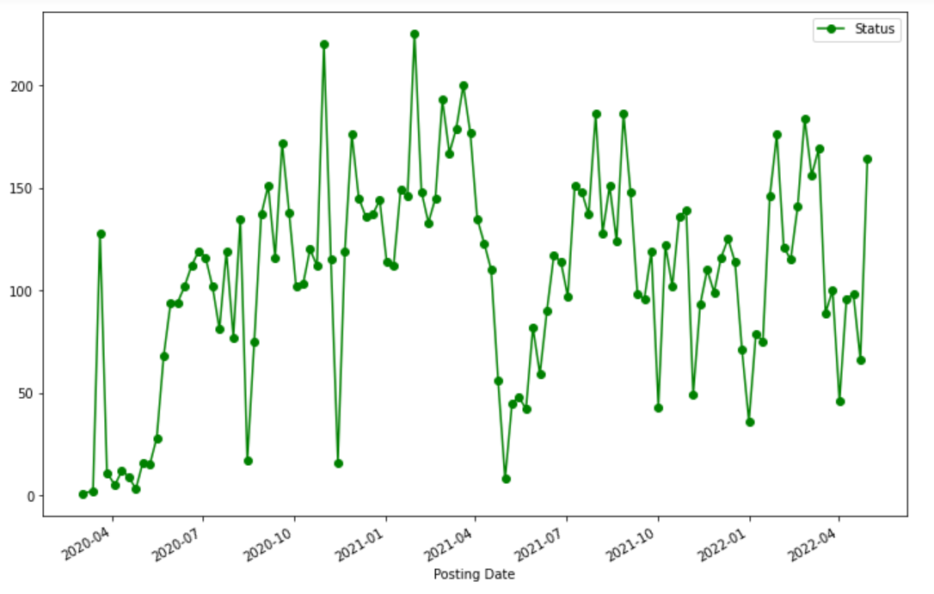

Sunday analysis

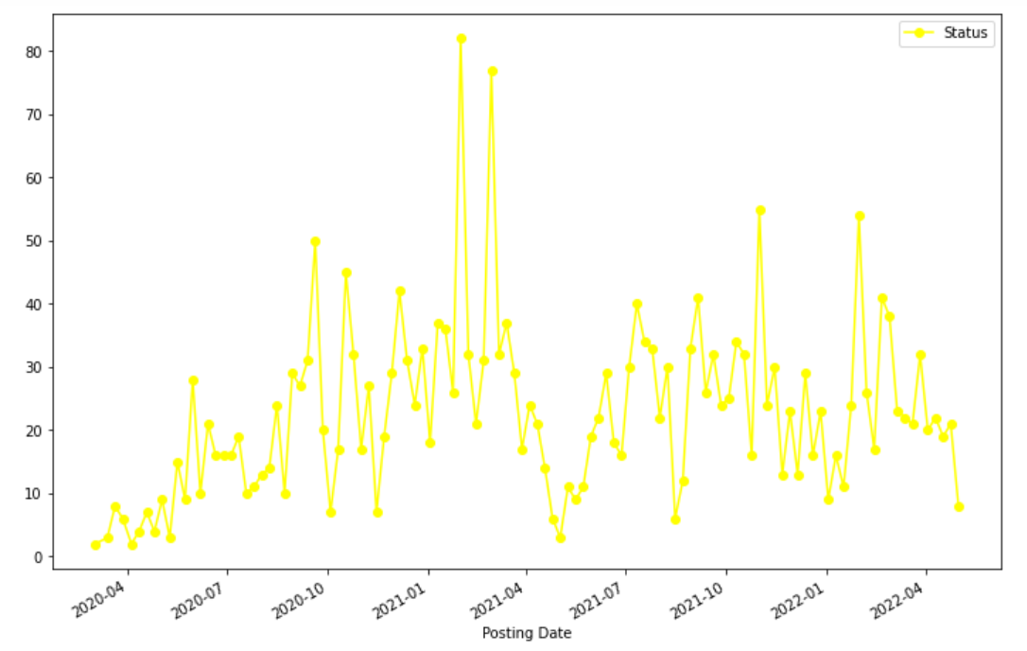

Monday analysis

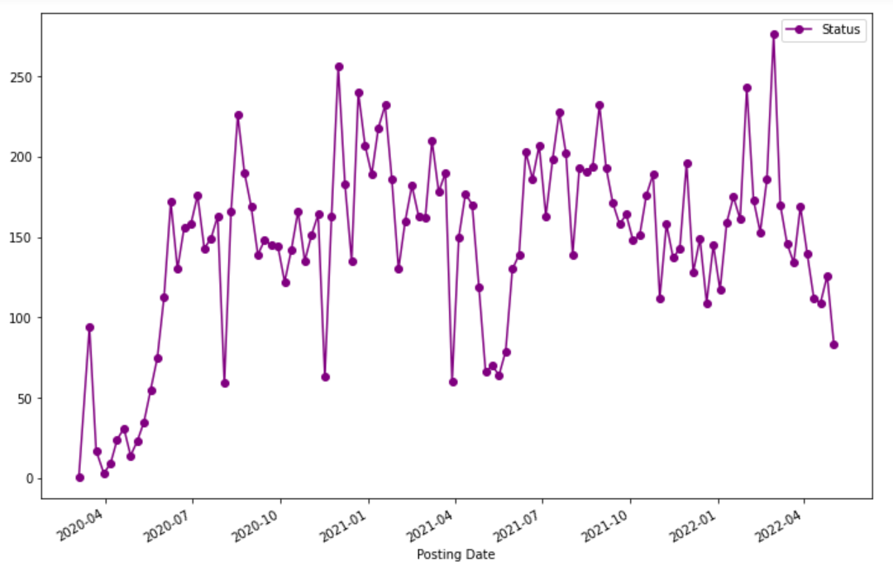

Tuesday analysis

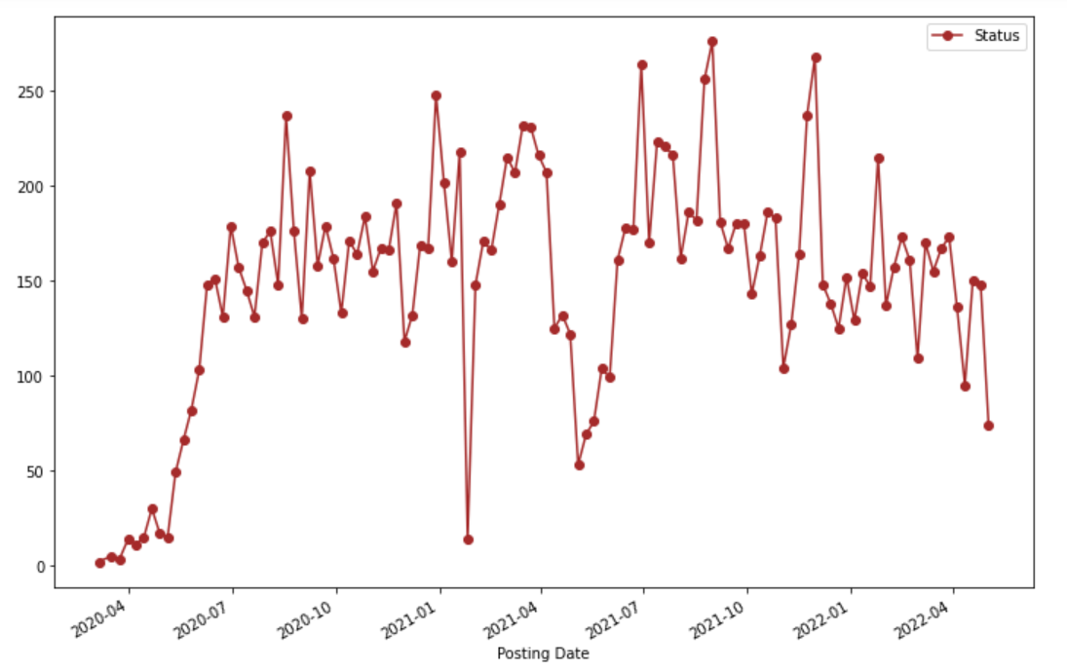

After the day wise analysis, we can see that Sundays have the least number of tickets.

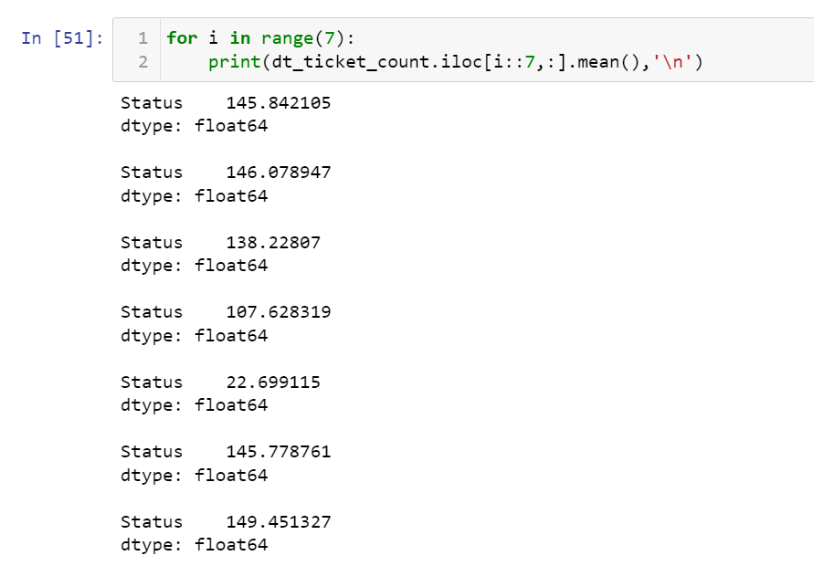



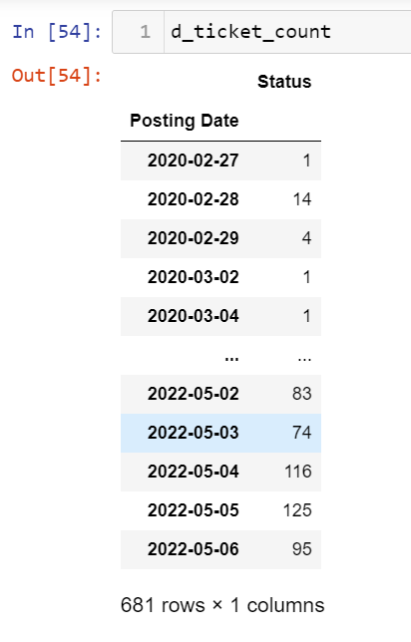 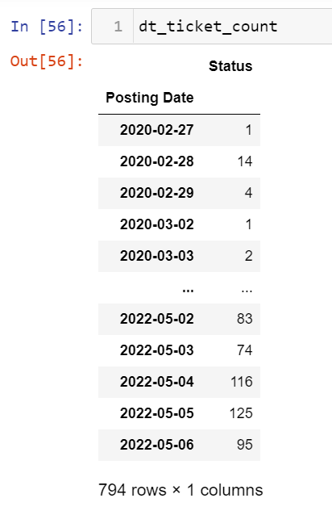

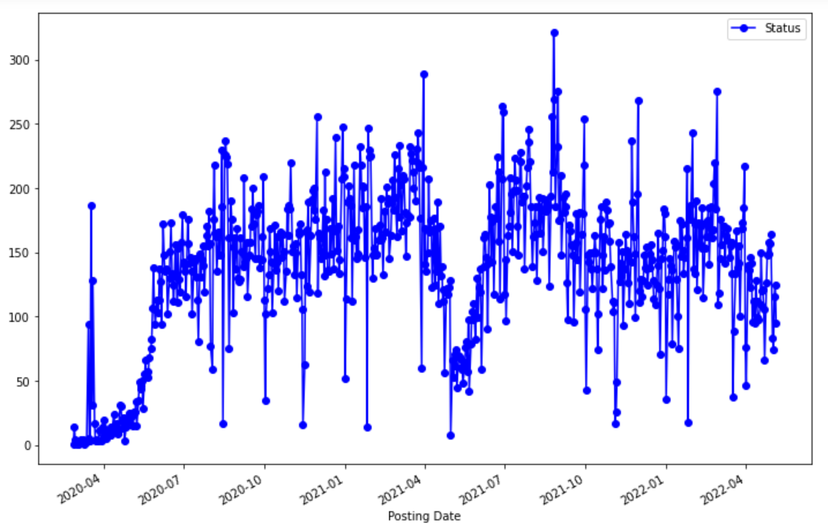

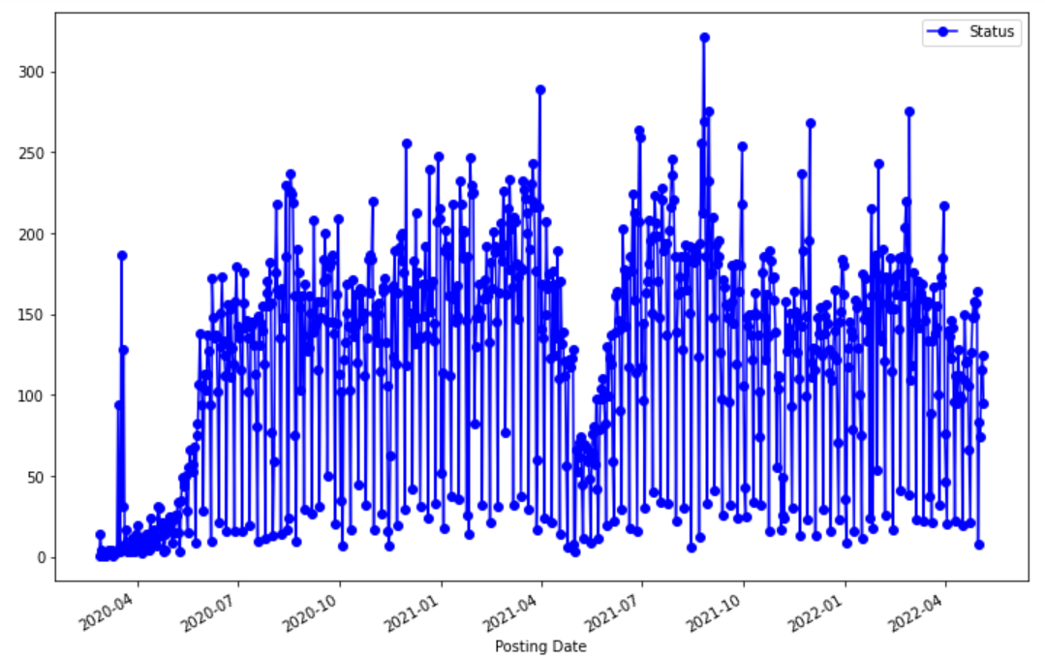

Now we will work on the data that do not contain Sunday



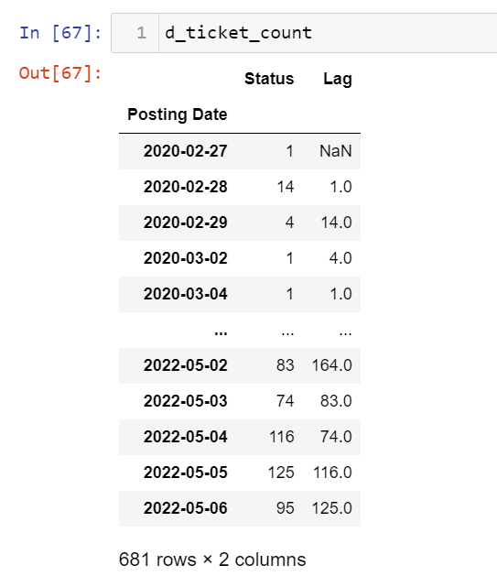

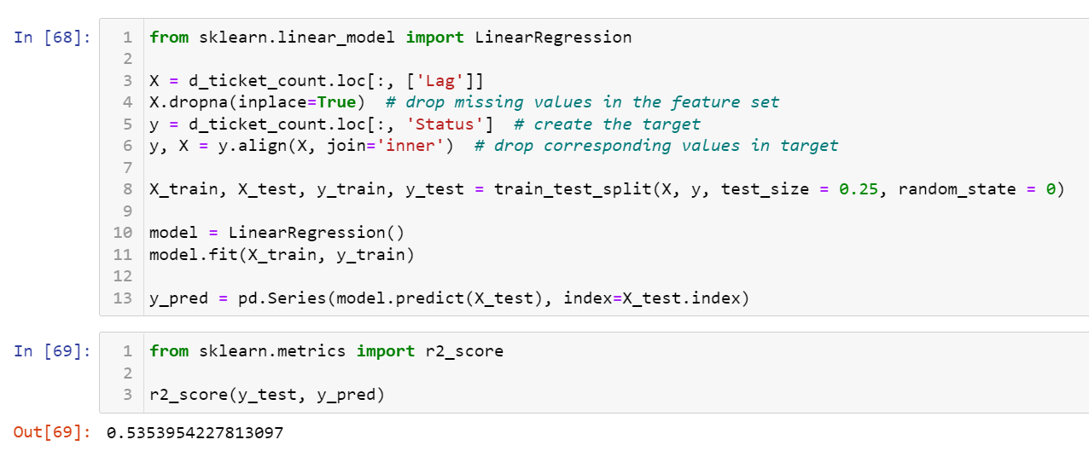

We got an accuracy of 53.53% with the linear regression model



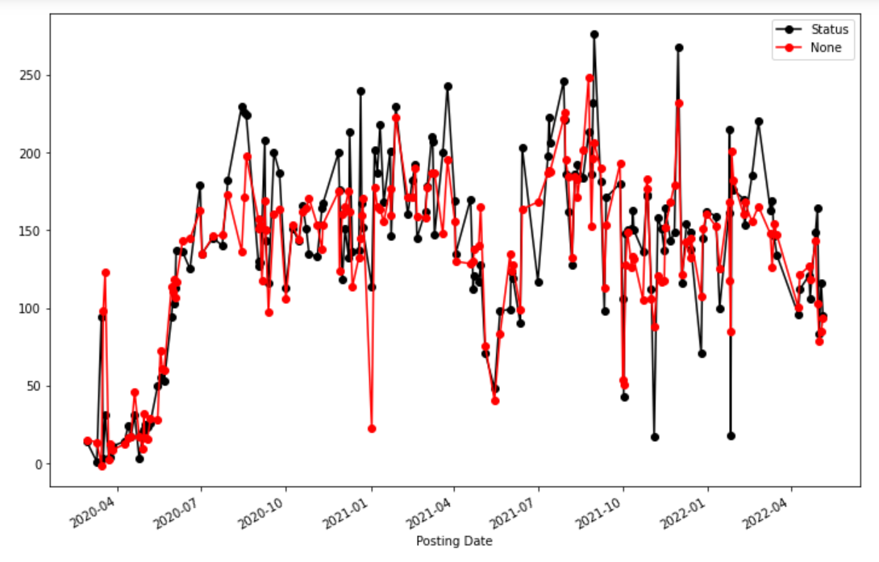

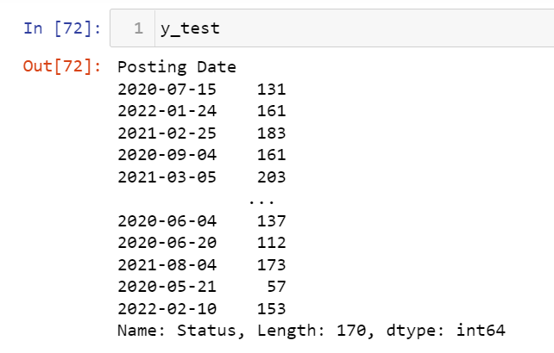

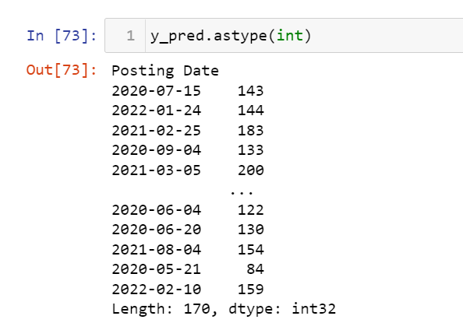

They above represented data is the actual and predicted data for the linear regression model.

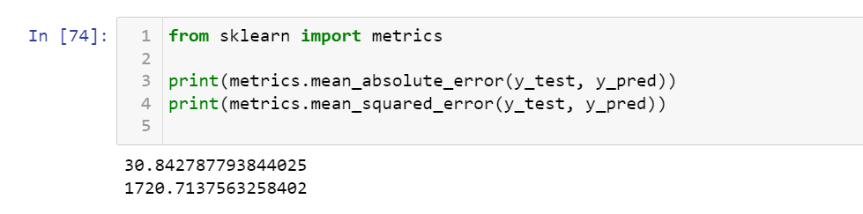

##### 5.3. XG Boost

In machine learning, **gradient boosting** is an algorithm that helps in performing regression and classification tasks. Using the ensemble of weak prediction models, gradient boosting helps us in making predictions. Examples of weak models can be decision trees. Ensembled models using weak tree learners can be considered gradient-boosted trees. Gradient-boosted trees are comparable to the random forest even though they can perform better than random forests if finely tuned. It helps in generalizing the other model by optimizing the arbitrary differential loss function.

XGBoost is a library that can help us regularize gradient boosting in different languages like python, R, Julia, c++, and Java. XGBoost stands for extreme gradient boosting machine. As software, the main focus of XGBoost is to speed up and increase the performance of gradient boosted decision trees.  This software can provide us with scalable, portable, and distributed gradient boosting. Using this library, we can utilize the functionality in single and distributed processing machines.

Gradient boosting is majorly focused on improving the performance of the machine learning models and with gradient boosting using XGBoost we can speed up the procedure as well as we can get better results. When we talk about the field of time series analysis and forecasting, we use traditional models like ARIMA (autoregressive integrated moving average) models where the main focus or the model is on regression analysis and if we can perform this regression with such software and technique, we can also achieve a state-of-the-art performance in the time series modelling. Ensemble of weak machine learning models to regularized gradient boosting can help us in improving the results in every section of data science. The section can also be time series. In this article, we will see how we can make XGBoost perform in time series modelling.

**XGBoost is faster than the LSTM method** with equal precision in the correct tuning parameters. The drawback is its feature-importance is not so accuracy as LSTM+SHAP combination.

So now we are using this model since it gave the best prediction values with a highest accuracy out of all the models in the past with an accuracy of 82.82% where the expected was around 70% and this can be concluded as the best

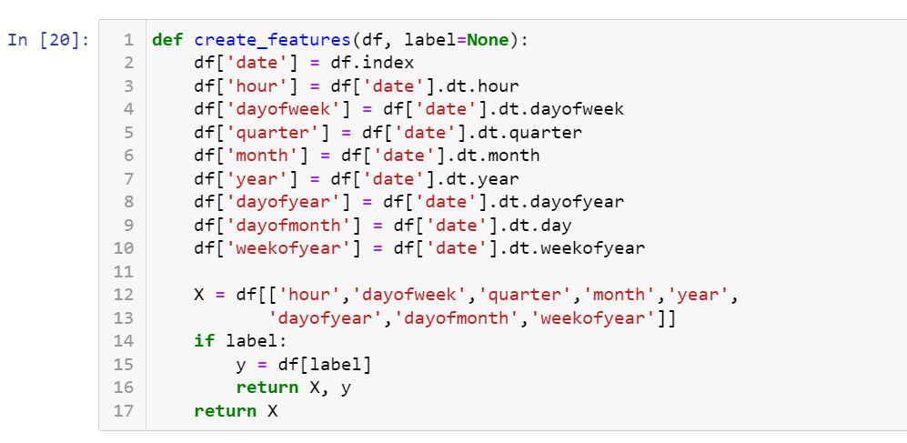

We are first creating features from the posting date, since it is the only predefined feature

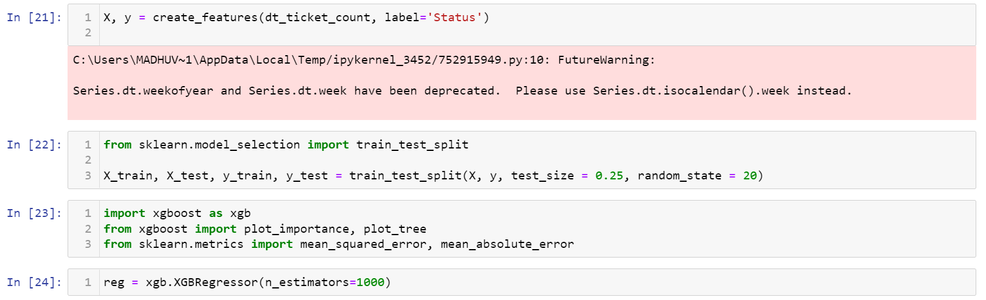

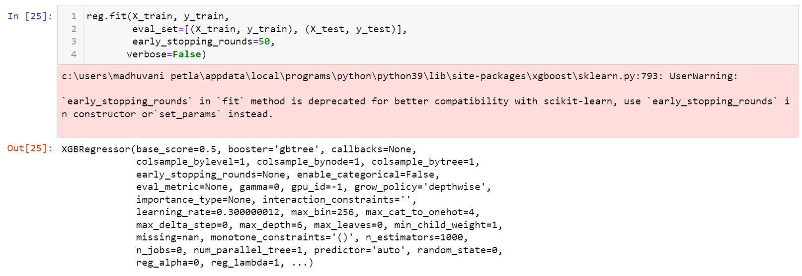

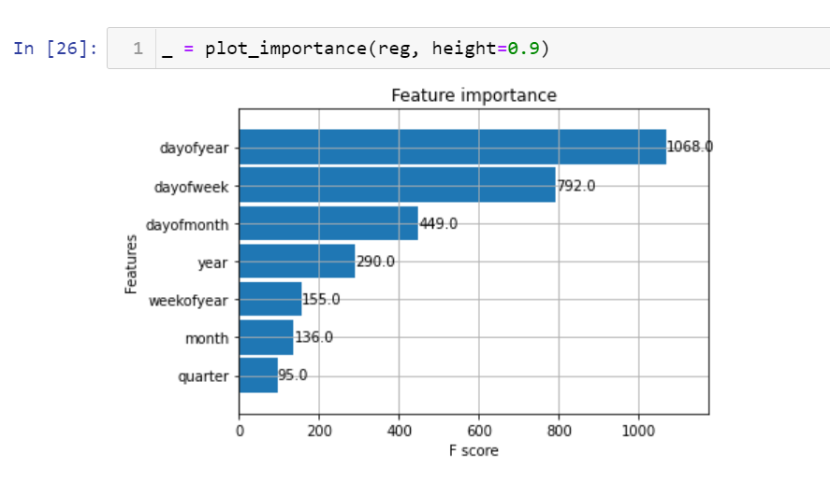

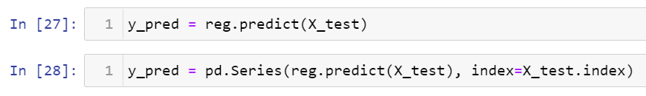

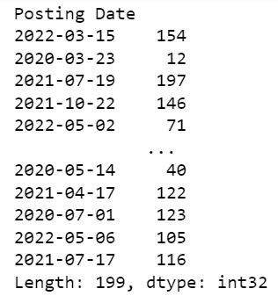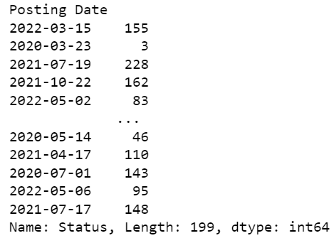

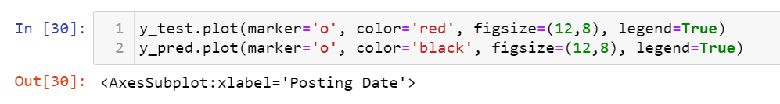

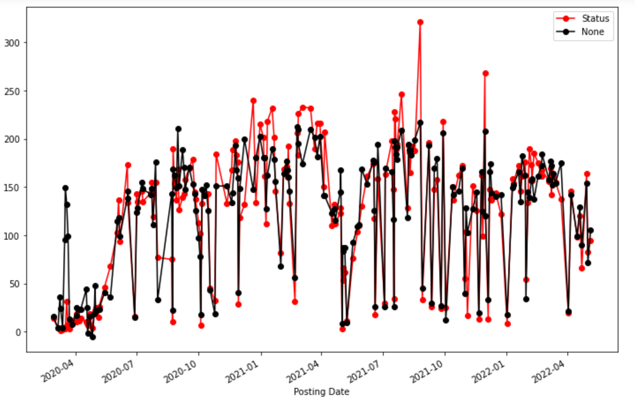

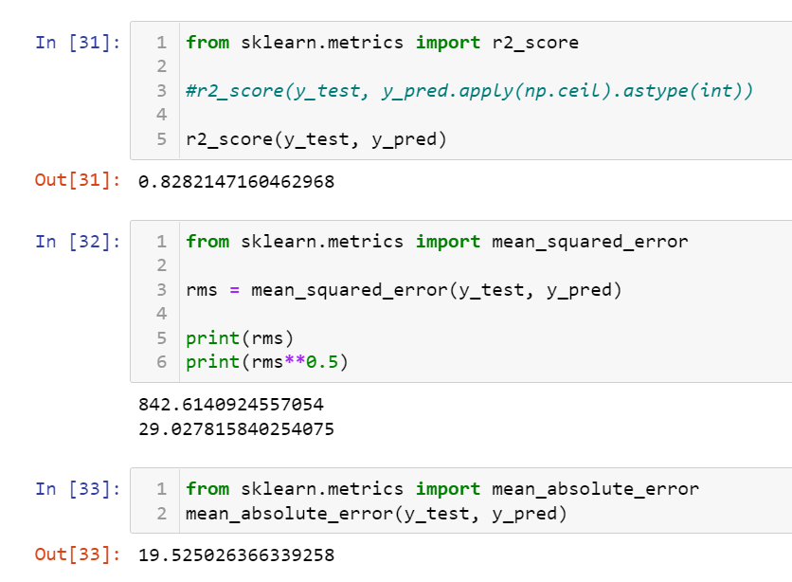

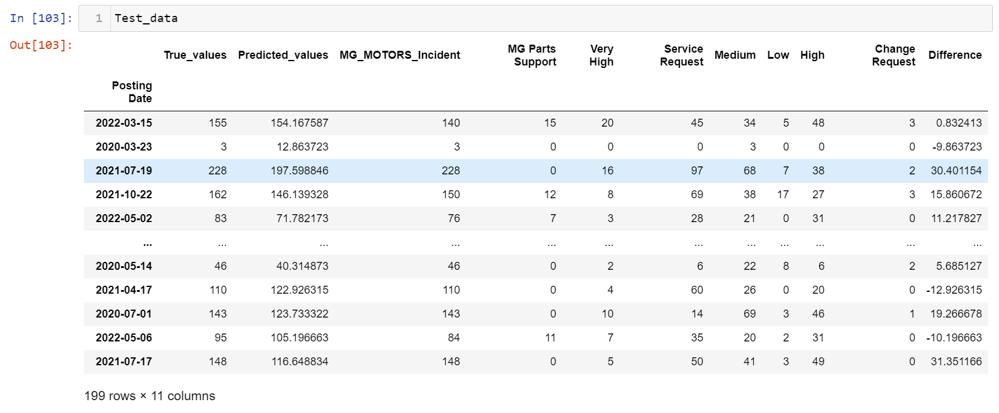

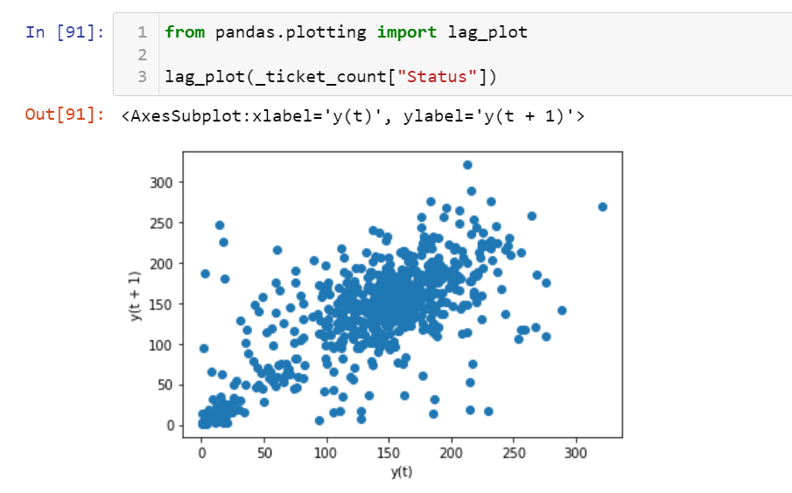

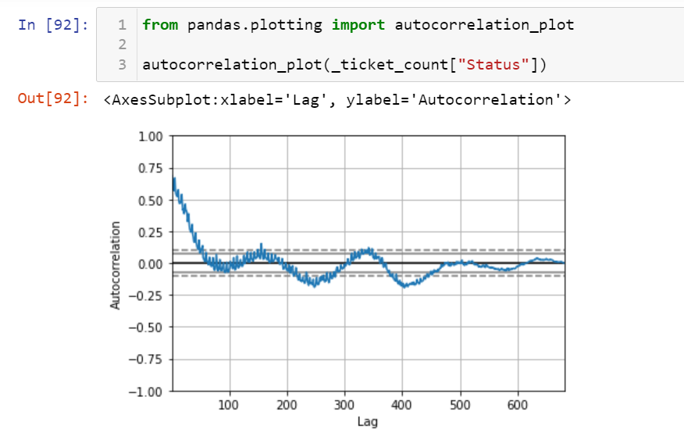

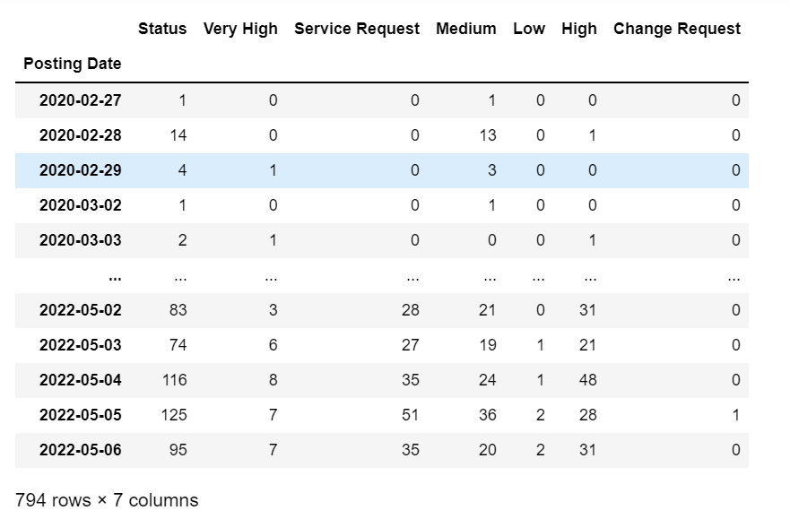

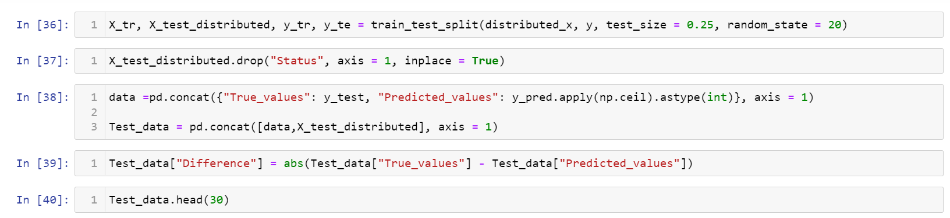

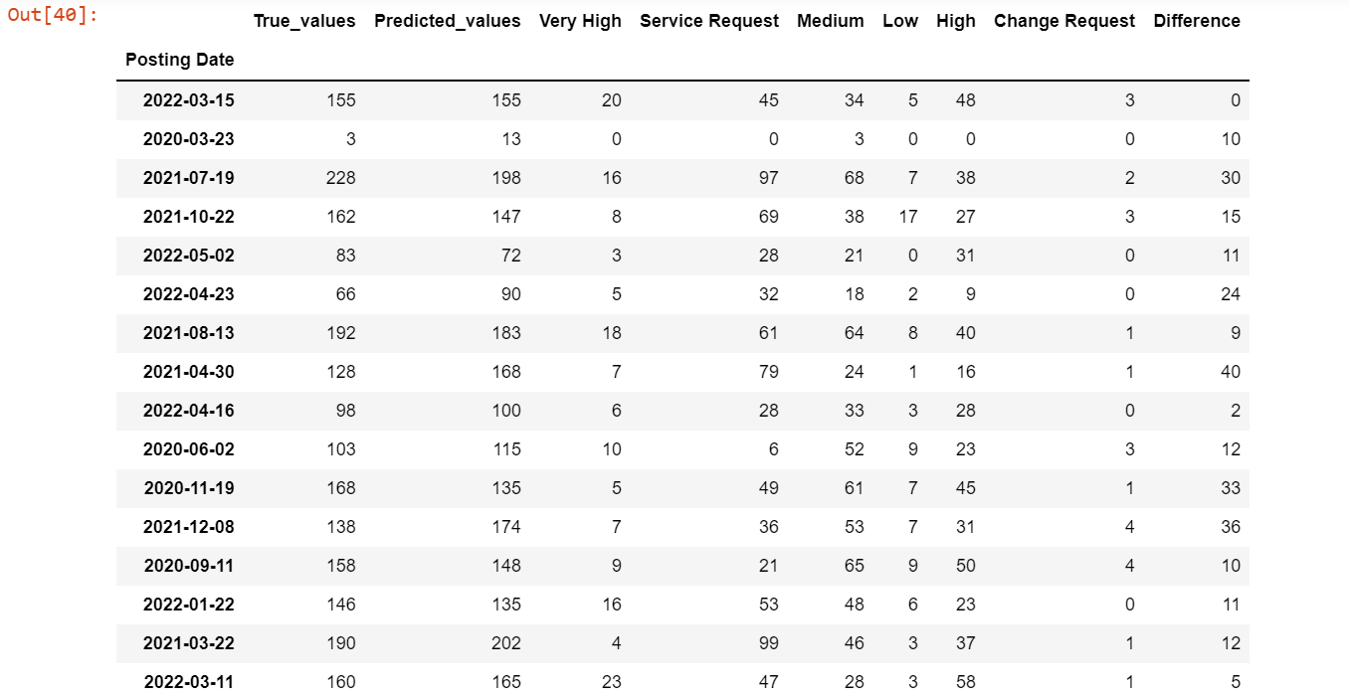

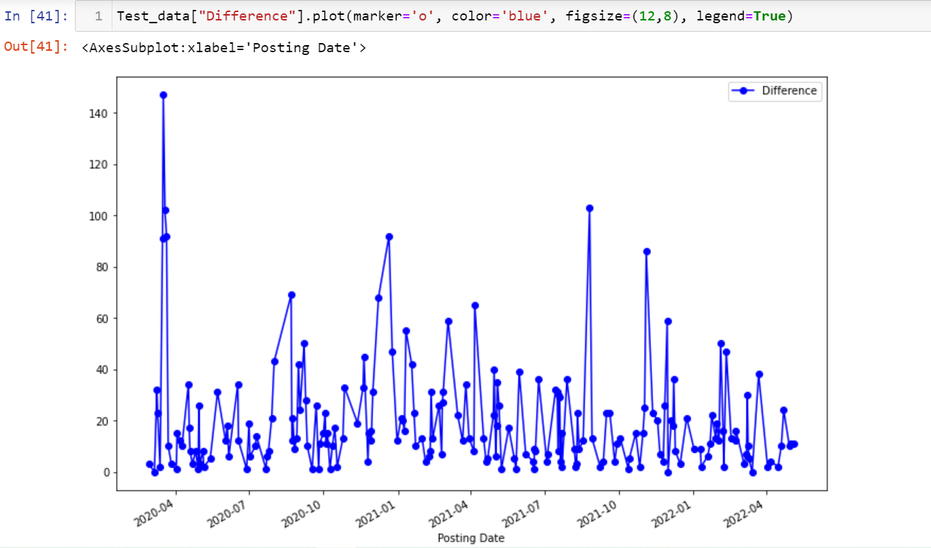

Now let us predict the multilabel prediction or the multi-target prediction

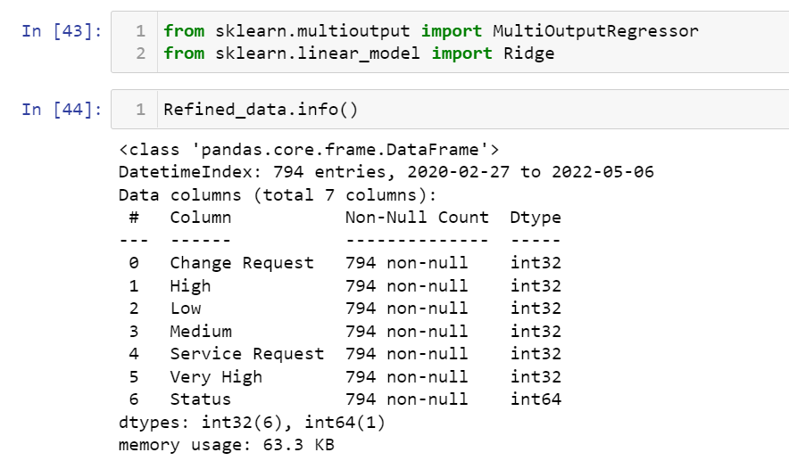

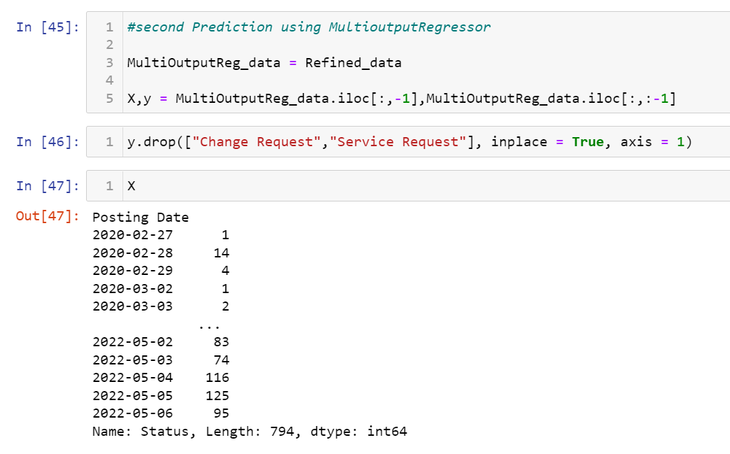

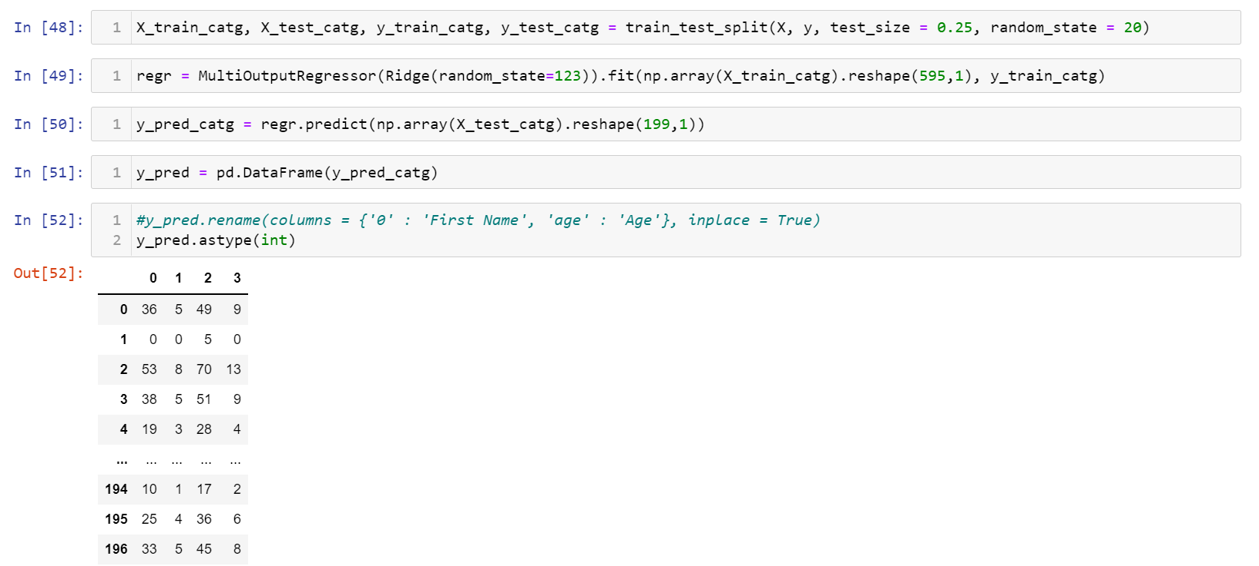

Now after the multivariate prediction let us predict the categorical values for very high and high priority

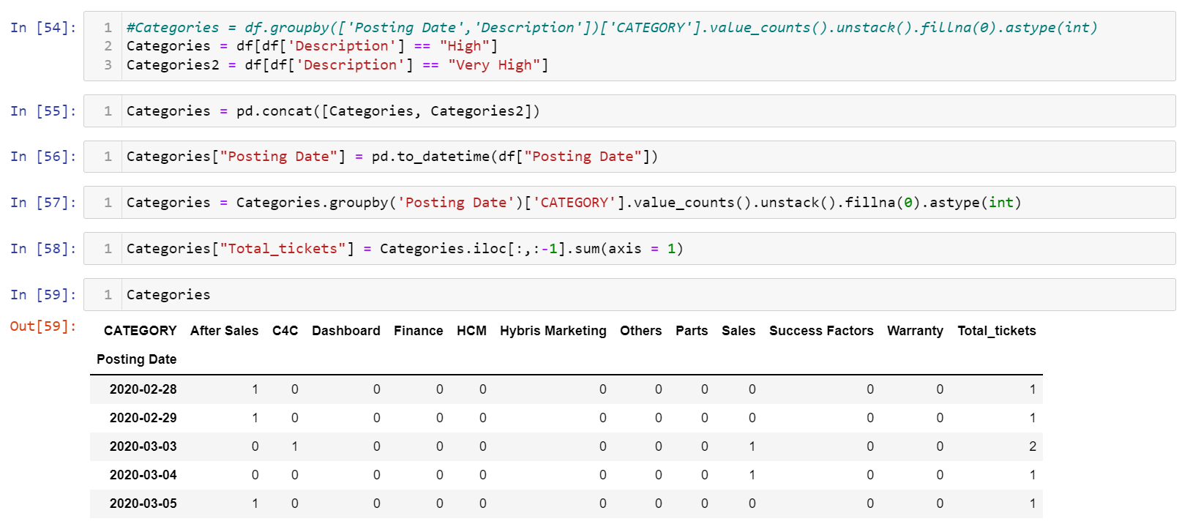

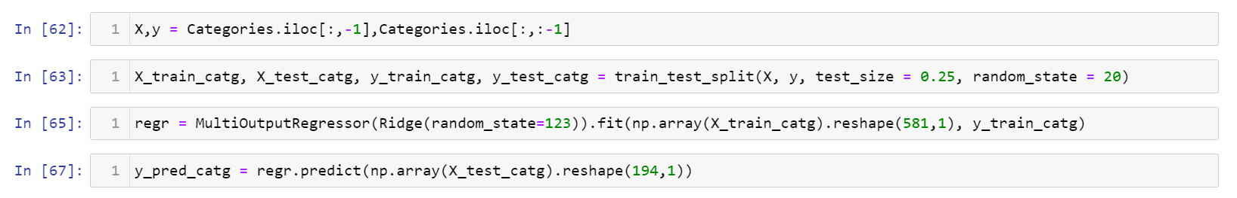

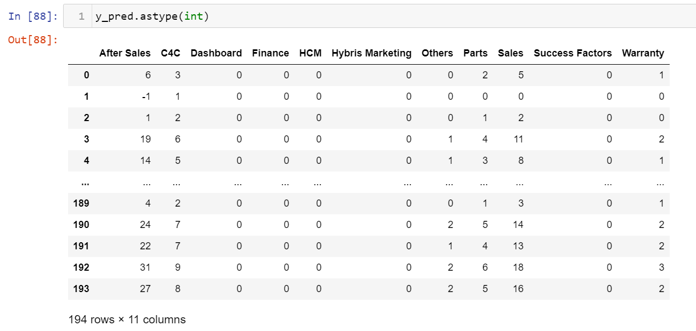

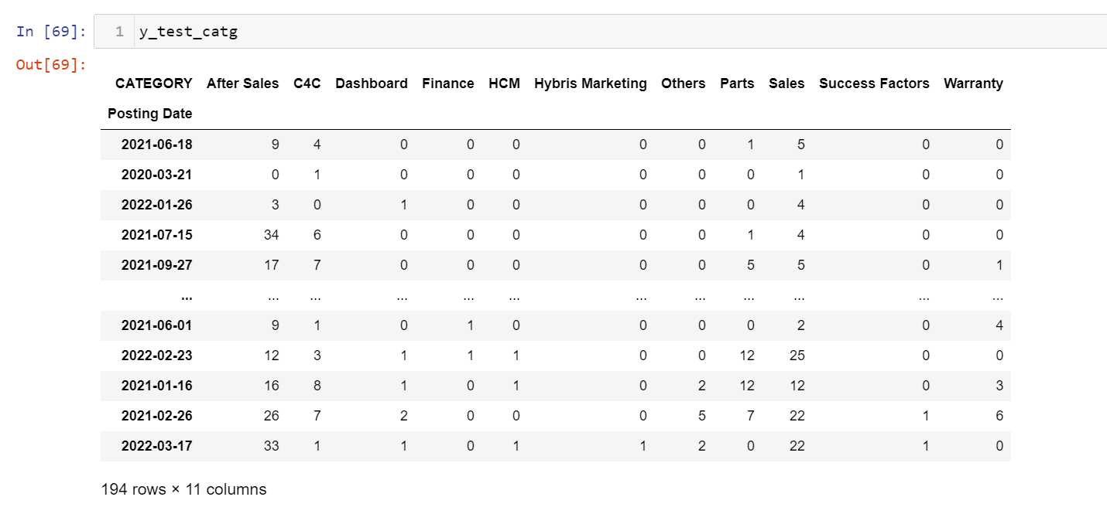

From the above prediction we can find the distributed data we get an accuracy of 90% since the mean squared error is around 10.

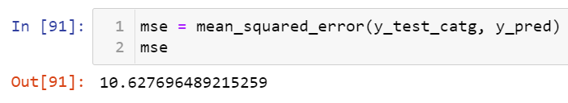

##### 5.4. Prediction for the next 6 months

Let’s create a data frame with next 6-month dates as the index

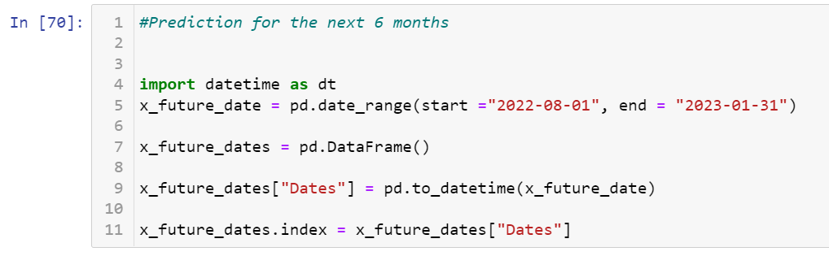

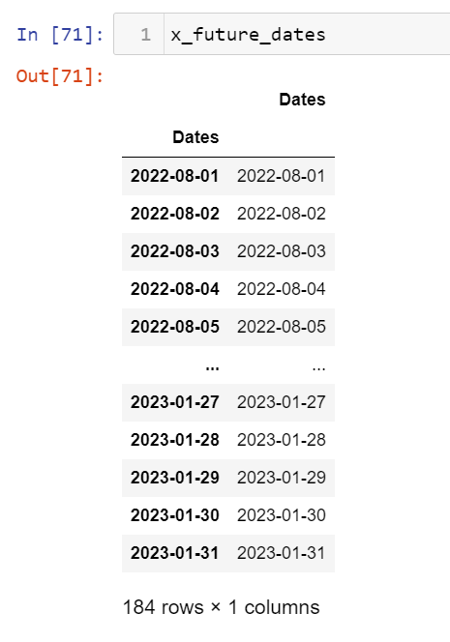

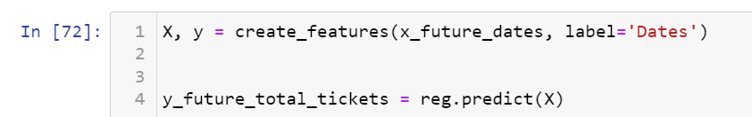

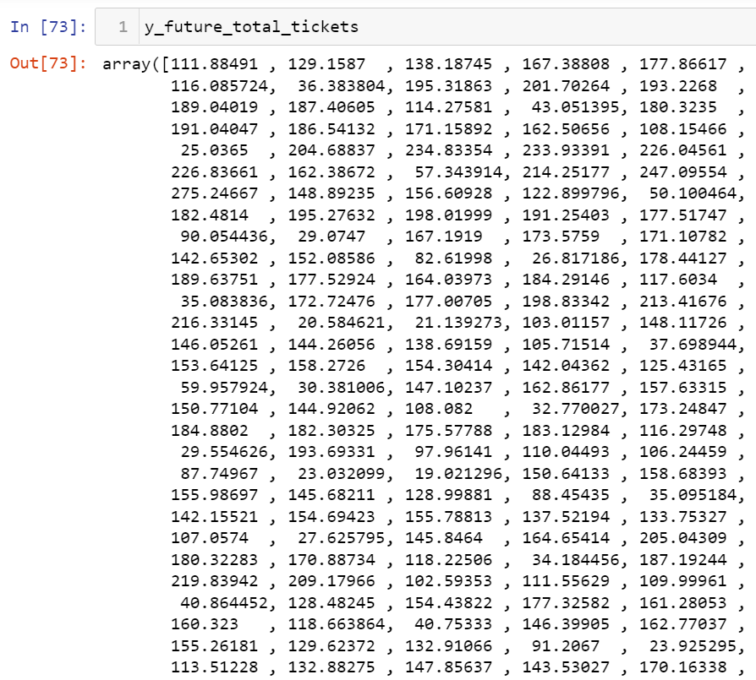

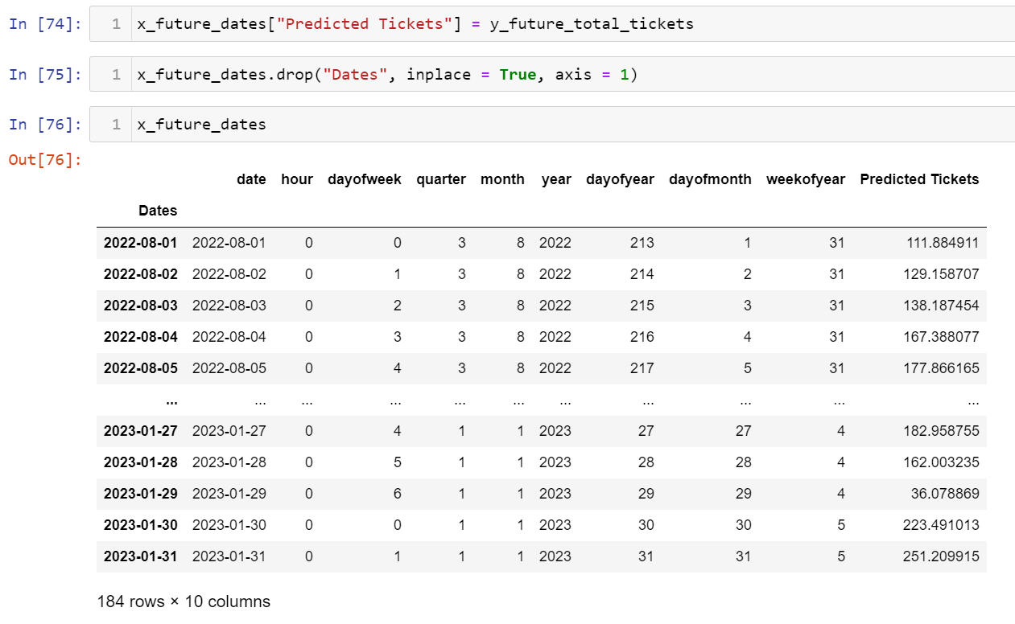

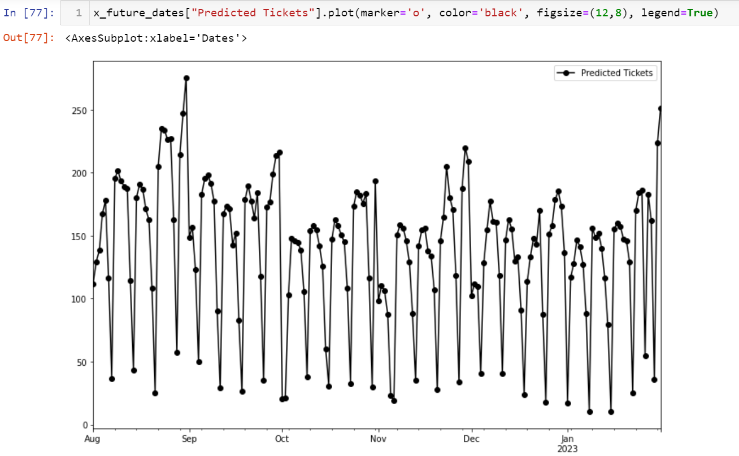

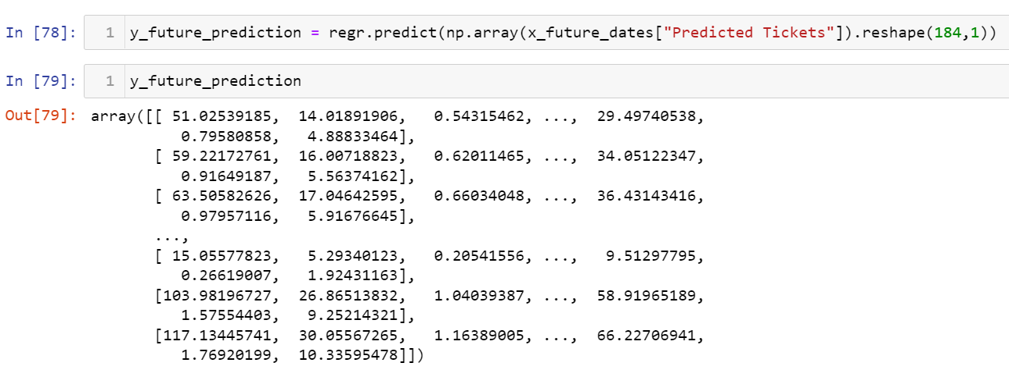

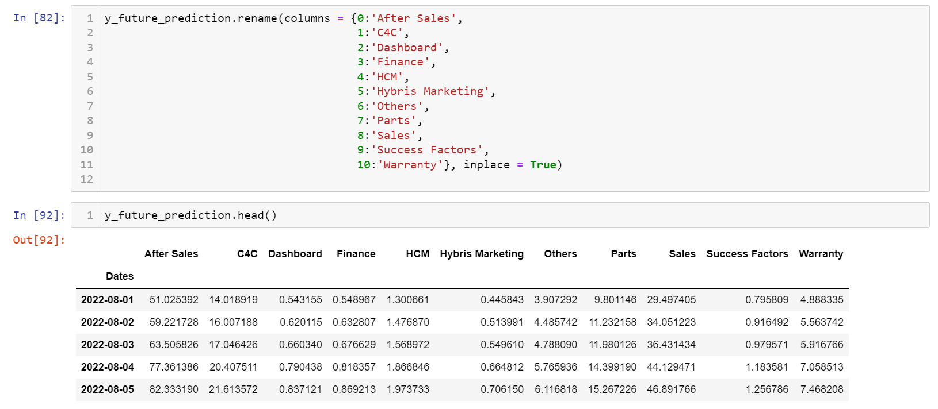

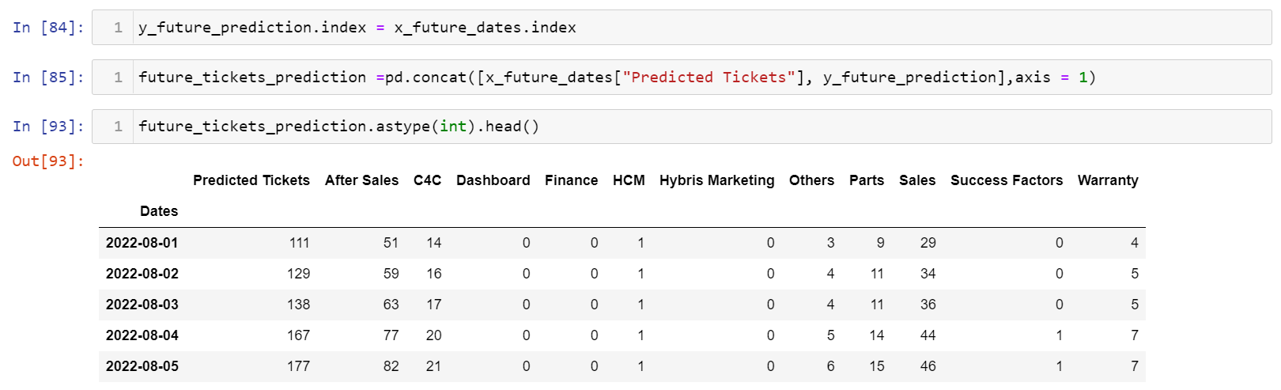

|  |  |  |
| --- | --- | --- |
|  | 6.Related Work |  |

1.[Food Analysis:](https://analyticsindiamag.com/how-to-use-xgboost-for-time-series-analysis/#:~:text=Using%20XGBoost%20for%20time%2Dseries,results%20and%20speed%20of%20modelling.&text=XGBoost%20is%20an%20efficient%20technique%20for%20implementing%20gradient%20boosting.)

Description:

The order values are moving around the range between 5 to 15 and our model is also predicting between this range. Using those predictions, we can tell the restaurant to prepare around this range only so that we can reduce the wastage of food and maximize profit.

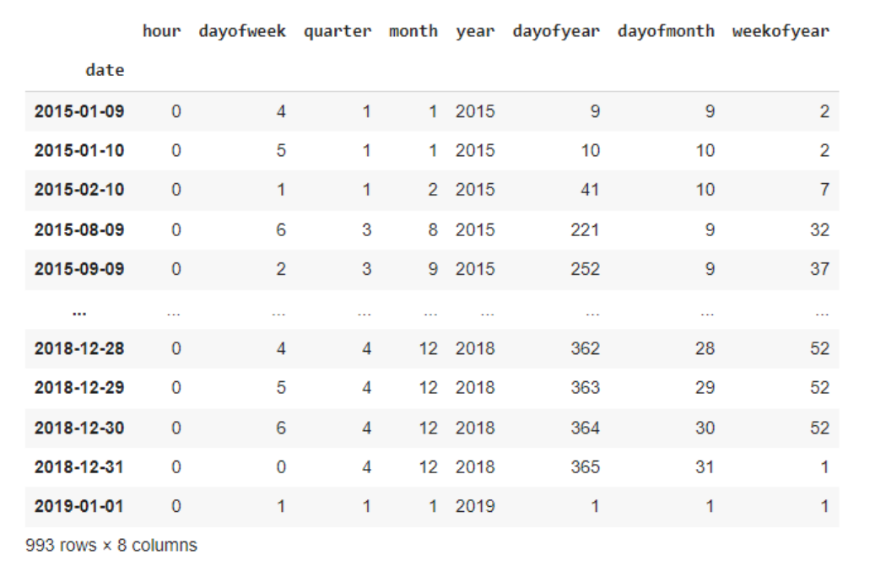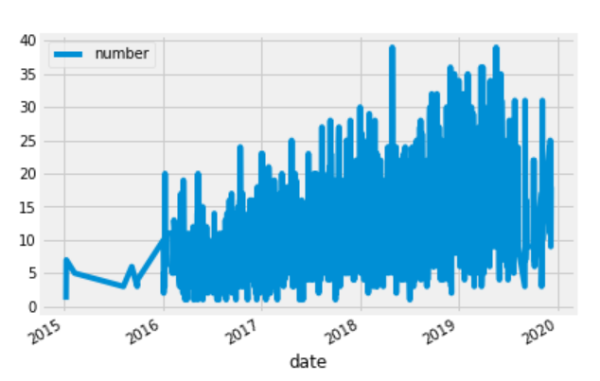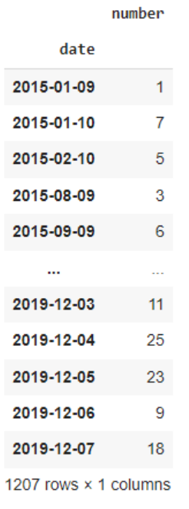

|  |  |  |
| --- | --- | --- |
|  | 7.Worklog |  |

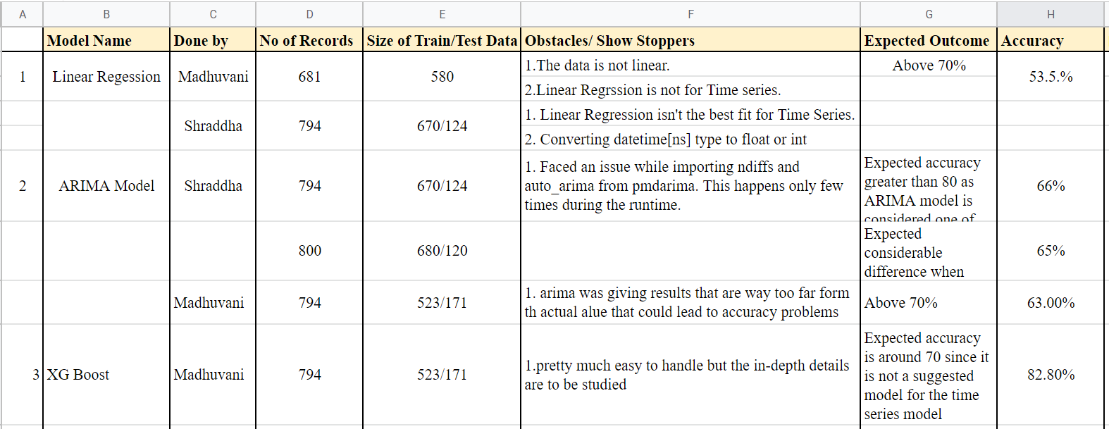

This is the worklog that has been created during the process of evaluation on the report

Link for the Worklog: [WORKLOG](https://docs.google.com/spreadsheets/d/15WQ7vwOqpRIdt4XKe2IcB1yk6ge56N3frtbeU4OC4Ow/edit?usp=sharing)

|  |  |  |
| --- | --- | --- |
|  | 8.Future Work |  |

Future work concerns deeper analysis of particular mechanisms, new proposals to try different methods, or simply curiosity.

The future work on the developed model can be as follows:

* Split the given data into categories and make predictions for further use
* Use this model as the base model for further predictions
* As we analyze the data, we can add better features into the data like
  + Adding the Boolean value of recent software updating period if it is less than a week add the value as true else false
  + This can help in using a multivariate prediction
* Then this prediction is to updated in the platform for the better business solutions

|  |  |  |
| --- | --- | --- |
|  | 9. References |  |

##### Websites and Blogs referred for this project

* [Time series](https://towardsdatascience.com/the-complete-guide-to-time-series-analysis-and-forecasting-70d476bfe775)
* [Arima](https://www.machinelearningplus.com/time-series/arima-model-time-series-forecasting-python/)
* [Linear regression](https://www.geeksforgeeks.org/ml-linear-regression/)
* [XGBoost](https://towardsdatascience.com/https-medium-com-vishalmorde-xgboost-algorithm-long-she-may-rein-edd9f99be63d)
* [Multi target Regression](https://towardsdatascience.com/regression-models-with-multiple-target-variables-8baa75aacd)
* [How to use XGBoost for time-series analysis?](https://analyticsindiamag.com/how-to-use-xgboost-for-time-series-analysis/#:~:text=Using%20XGBoost%20for%20time%2Dseries,results%20and%20speed%20of%20modelling.&text=XGBoost%20is%20an%20efficient%20technique%20for%20implementing%20gradient%20boosting.)
* [11 Classical Time Series Forecasting Methods in Python (Cheat Sheet)](https://machinelearningmastery.com/time-series-forecasting-methods-in-python-cheat-sheet/)
* [Time Series Analysis: Definition, Types & Techniques | Tableau](https://www.tableau.com/learn/articles/time-series-analysis#:~:text=Time%20series%20analysis%20is%20a,data%20points%20intermittently%20or%20randomly.)
* [Univariate-Time-Series-using-LSTM](https://github.com/dhamvi01/Univariate-Time-Series-using-LSTM/blob/master/airline-passengers.csv)
* [Understanding input shape parameter in LSTM with Keras - Cross Validated](https://stats.stackexchange.com/questions/274478/understanding-input-shape-parameter-in-lstm-with-keras)
* [Deep Learning Models for Univariate Time Series Forecasting](https://machinelearningmastery.com/how-to-develop-deep-learning-models-for-univariate-time-series-forecasting/)
* [time-series-analysis](https://github.com/stxupengyu/time-series-analysis/blob/master/time_series_analysis_prediction.ipynb)
* [GitHub - stxupengyu/time-series-analysis: 使用经典的AR、MA、ARMA、ARIMA、ARCH、GARCH时间序列模型进行模型的检验和拟合。The classic AR, MA, ARMA, ARIMA, ARCH, GARCH time series models are used to test and predict the model.](https://github.com/stxupengyu/time-series-analysis/blob/master/time_series_analysis_prediction.ipynb)
* [auto-regressive-time-series-model/AR-model-notebook.ipynb at master · bhattbhavesh91/auto-regressive-time-series-model · GitHub](https://github.com/bhattbhavesh91/auto-regressive-time-series-model/blob/master/AR-model-notebook.ipynb)
* [statsmodels.tsa.ar_model. AutoReg.predict — stats models](https://www.statsmodels.org/dev/generated/statsmodels.tsa.ar_model.AutoReg.predict.html)
* [Autoregression Models for Time Series Forecasting with Python](https://machinelearningmastery.com/autoregression-models-time-series-forecasting-python/)
* [What Is Time Series Forecasting?](https://machinelearningmastery.com/time-series-forecasting/)
* [Time Series Forecasting with Prophet in Python](https://machinelearningmastery.com/time-series-forecasting-with-prophet-in-python/)
* [ARIMA vs Prophet vs LSTM for Time Series Prediction - neptune.ai](https://neptune.ai/blog/arima-vs-prophet-vs-lstm#:~:text=LSTM%20stands%20for%20Long%20short,not%20restricted%20to%20time%20series.)
* [A Gentle Introduction to the Box-Jenkins Method for Time Series Forecasting](https://machinelearningmastery.com/gentle-introduction-box-jenkins-method-time-series-forecasting/)
* [6.4.4. Univariate Time Series Models](https://www.itl.nist.gov/div898/handbook/pmc/section4/pmc44.htm)
* [Time Series Forecasting with Regression and LSTM | Paper space Blog](https://blog.paperspace.com/time-series-forecasting-regression-and-lstm/)
* [Python | ARIMA Model for Time Series Forecasting - GeeksforGeeks](https://www.geeksforgeeks.org/python-arima-model-for-time-series-forecasting/)
* [A Gentle Introduction to Exponential Smoothing for Time Series Forecasting in Python](https://machinelearningmastery.com/exponential-smoothing-for-time-series-forecasting-in-python/#:~:text=Single%20Exponential%20Smoothing%2C%20SES%20for,smoothing%20factor%20or%20smoothing%20coefficient.)
* [statsmodels.tsa.holtwinters.SimpleExpSmoothing — stats models](https://www.statsmodels.org/dev/generated/statsmodels.tsa.holtwinters.SimpleExpSmoothing.html)
* [Support vector machine models in drug design](https://www.sciencedirect.com/science/article/abs/pii/S0925231203003746)
* [Support Vector Machine (SVM) Algorithm - Javatpoint](https://www.javatpoint.com/machine-learning-support-vector-machine-algorithm)
* [How to Select a Model for Your Time Series Prediction Task [Guide] - neptune.ai](https://neptune.ai/blog/select-model-for-time-series-prediction-task)
* [Intro to Time Series Forecasting | Kaggle](https://www.kaggle.com/code/iamleonie/intro-to-time-series-forecasting/notebook)
* [Matplotlib documentation — Matplotlib 3.5.2 documentation](https://matplotlib.org/stable/index.html)
* [Logistic Regression in Python – Real Python](https://realpython.com/logistic-regression-python/#:~:text=The%20logistic%20regression%20function%20%F0%9D%91%9D(%F0%9D%90%B1)%20is%20the%20sigmoid%20function,%F0%9D%90%B1%20is%20equal%20to%201.)
* [sklearn.multioutput.MultiOutputRegressor — scikit-learn 1.1.1 documentation](https://scikit-learn.org/stable/modules/generated/sklearn.multioutput.MultiOutputRegressor.html#sklearn.multioutput.MultiOutputRegressor.fit)

These are references that are considered in the entire project

Videos/courses:

* [Univariate Time Series Models || Forecasting || Data Science](https://www.youtube.com/watch?v=uZ_LyQYrGY4&t=2s)
* [Time Series Forecasting Theory | AR, MA, ARMA, ARIMA | Data Science](https://www.youtube.com/watch?v=Aw77aMLj9uM&t=435s)
* [Auto Regressive Time Series Model in Python](https://www.youtube.com/watch?v=4O9Rkzm8Q5U&t=553s)
* [Autoregressive Models | Auto Regression | Machine Learning for Beginners | Edureka](https://www.youtube.com/watch?v=wJASx5-mnuc)
* [Time Series Analysis | Time Series Forecasting | Time Series Analysis In Excel | Simplilearn](https://www.youtube.com/watch?v=chp71nEc320&t=3s)
* [Time Series Analysis in Python | Time Series Forecasting | Data Science with Python | Edureka](https://www.youtube.com/watch?v=e8Yw4alG16Q&t=1981s)
* [The Box Jenkins Models](https://www.youtube.com/watch?v=ZL6B5udI6PA&t=1273s)

|  |  |  |
| --- | --- | --- |
|  | 10.Technologies used |  |

Scripting Language: Python

* NumPy
* Pandas
* Scikit Learn
* Matplotlib
* Arima Time series model
* XGBoost Time series model
* Seaborn

**Jupyter Notebook** is used for the entire execution of the model

|  |  |  |
| --- | --- | --- |
|  | 10.Conclusions |  |

According to the analysis:

* The given data is a univariate data with date as the important feature
* The data consists of classification of tickets into different categories
* Categories involved in the data are
  + Description
  + Status
  + Category
  + Zone
  + Transaction type
* Time-series model can be applied on such data for future predictions
  + ARIMA
  + AR
  + MA
  + XGBOOST
  + LSTM
* **ARIMA** model gave us an accuracy of **58%**
* **Linear Regression** gave us an accuracy of **53.5%**
* **XGBOOST** gave us an accuracy of **82.8%**
* Since XGBOOST gave us highest accuracy we can make further predictions using the XGBOOST.
* For the further predictions MULTI TARGET REGRESSION is used
* Multi output regressor has given us an accuracy of **90%** which is pretty much a higher accuracy
* GitHub: [Ticket Prediction](https://github.com/Madhuvani5103/TicketPredictionTimeSeriesAnalysis)